Relational Intelligence: Who Is At Your Table?

The Glue That Holds: Part 2

Dr. Tony Soldano

April 21, 2024

CENTRAL TRUTH

There is a relational bond (glue) that is created by the Spirit of God that holds people together. The two main ingredients of the glue are peace and love.

SERMON QUESTIONS & OBJECTIVES

- What do they need to know?
- God creates a bond that keeps relationships together.

- Why do they need to know it?
- The responsibility of the believer is to guard the unity of the faith.

- How should they apply it?
- The believer should do everything possible to live in peace and love.

OPENING LINE

The Scriptures place a great emphasis on followers of Christ, living in peace and harmony, and getting along with one another.

INTRODUCTION OF THE SERMON

There was a TV commercial a while ago for a super glue. The advertisers chose to show how strong that glue was by suspending a man from a steel beam of a high rise building by the man’s construction hard hat. In God, we have a bond that is stronger than any glue.

READING – MAIN PASSAGE

Unity in the Body of Christ

Ephesians 4:1-3
¹ I, therefore, the prisoner of the Lord, beseech you to walk worthy of the calling with which you were called, ² with all lowliness and gentleness, with longsuffering, bearing with one another in love,
³ endeavoring to keep the unity of the Spirit in the bond of peace.

Colossians 3:14-15
¹⁴ But above all these things put on love, which is the bond of perfection. ¹⁵ And let the peace of God rule in your hearts, to which also you were called in one body; and be thankful.

TRANSITION STATEMENT

If we are going to display Kingdom relationships, we are going to have to have a high-level of emotional intelligence. This includes a high degree of self-awareness.

INTRAPERSONAL VERSUS INTERPERSONAL EMOTIONAL INTELLIGENCE (EQ)

- Intra emotional intelligence: Self-awareness, and the ability to assess one zone emotions, heart, and state. It deals with remiss issues and triggers responding to certain situations and scenarios.

- Inter emotional intelligence: The ability to interact with others to assess their emotions and states. It also means the ability to read people, situations, and scenarios and how to best handle them.

MAIN POINTS

What contributes to the BOND of relationships?

- Having meaningful and truthful conversations with people is critical to relationships. This help to guard the unity of the faith:

  - Communication that is open, truthful, and filled with grace is essential in Kingdom relationships
- Seek to live in peace with one another, avoiding division and strife (Romans 12:16; Ephesians 4:3)

Romans 12:16-18
¹⁶ Be of the same mind toward one another. Do not set your mind on high things, but associate with the humble. Do not be wise in your own opinion. ¹⁷ Repay no one evil for evil. Have regard for good things in the sight of all men. ¹⁸ If it is possible, as much as depends on you, live peaceably with all men.

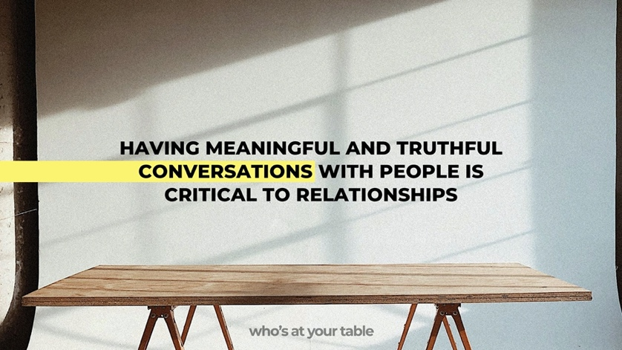

  - BOND - G4886 (Thayer)
- Συ-νδεσμος - sundesmos
- Thayer Definition:
- 1) That which binds together, a band, bond
- 1a) Of ligaments by which the members of the human body are united together
- 2) That which is bound together, a bundle.
  - What are some of the aspects that defined truthful and meaningful conversations?
- The truth must be spoken in love
- All parties must seek to bring a value to the relationship by not being self-serving, but rather, being contributors. In other words, we should seek to add rather than to subtract.
- Mass connection is not connection or relationship
- Just having access to people is not the answer
- The soul longs for meaningful connection.

- UNITY: Be on guard against the seeds of division, discord, and dissention

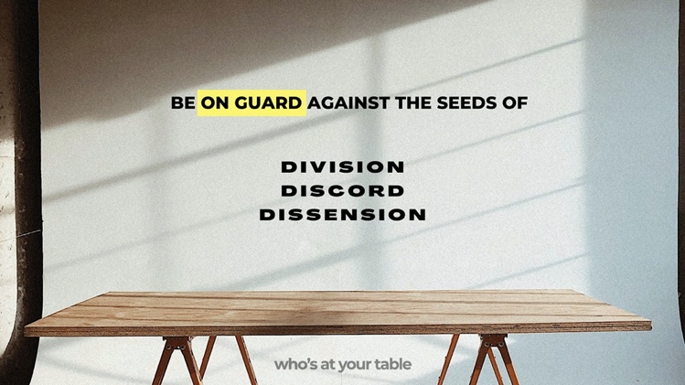

  - Unity and Harmony: Christians are called to pursue unity and harmony in their relationships. They should seek to live in peace with one another, avoiding division and strife (Romans 12:16; Ephesians 4:3).

  - Avoiding Discord and Division: Paul warns against behaviors that can harm relationships, such as gossip, bitterness, and division. In Ephesians 4:29-32, he urges believers to speak only what is helpful for building others up, to get rid of all bitterness, rage, anger, harsh words, and slander, and to be kind and compassionate to one another, forgiving each other, just as in Christ, God forgave you.

Ephesians 4:29-32
²⁹ Let no corrupt word proceed out of your mouth, but what is good for necessary edification, that it may impart grace to the hearers. ³⁰ And do not grieve the Holy Spirit of God, by whom you were sealed for the day of redemption. ³¹ Let all bitterness, wrath, anger, clamor, and evil speaking be put away from you, with all malice. ³² And be kind to one another, tender hearted, forgiving one another, even as God in Christ forgave you.

  - Unity is achievable when we have:
- Trust – Ultimate trust is achieved when your words and your heart have been heard, and understood

- Grace – Must be applied because everyone is at a different level of relationship, people are in the growth process.

  - Satan loves to attack the bond that exists between the believers in Christ. He knows that creating friction will cause them to lose their strength and their blessing. In fact, the entire demonic realm, salivates over creating confusion and disorder amongst God’s people.
- Behaviour such as gossiping and backbiting works into the hands of the enemy because he knows that God’s people will literally devour each other
- By contrast, the early church had to tarry for ten days before the Holy Ghost was poured out.

  - Question: Can we have boundaries and still experience unity?

The simple answer is yes, but it is much more complicated than that. The biblical term unity means that people are like-minded and that they are united in common values, purpose, and goals. Particularly, they desire to see the same outcomes and to do it together. However, without boundaries is not wise because it can lead to others being taken advantage of.

Throughout Scripture, starting in the Garden of Eden, God sets boundaries, and His expectations were that those boundaries would be kept.

Consider the Wedding Feast of the Lamb, people were rejected because they lacked the proper garments. Specifically, they had crossed the boundary and they were being held accountable. Therefore, God creates boundaries to protect His people. It is critical, that we understand our role in the Body of Christ, just as in the natural body—it functions well because the various parts understand their role. Only the blood that flows through the entire body does not seem to have any boundaries, and we know that life is in the blood. Therefore, when people cross into our boundaries unknowingly, we should correct them with grace and love.

  - Some people seem to have a master’s degree in causing drama

  - Unity at any cost is not wise.

- Healthy relationships require boundaries and healthy boundaries require respect and honour

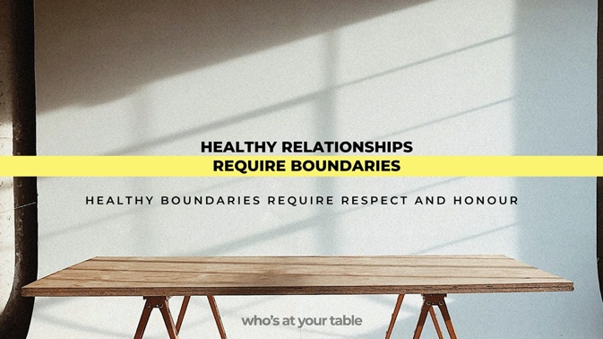

  - Is it possible to have boundaries and at the same time experience unity?

  - Good and healthy boundaries are rooted in honour and respect for one another.
- Everyone desires to be respected, but not everyone is respectful to everyone else.

  - A good test for a relationship is how a person responds to the word “No” ~Henry Cloud

  - Boundaries: Setting healthy boundaries is important in Christian relationships. Boundaries help protect individuals and maintain mutual respect and integrity (Proverbs 4:23; Galatians 6:5).

- Proverbs 4:23
Keep your heart with all diligence, for out of it spring the issues of life.

- Galatians 6:5
For each one shall bear his own load.

- Who has refrigerator rights in your house?
- Example of Pastor Moses at the house.
- God sets boundaries in His Word and sets lines that should not be crossed, they include:
- Sin
- In the Garden of Eden
- For demons who crossed lines
- Oceans
- Stars.

- What is the difference between walls and boundaries?
- The basic difference is that walls imply a more negative effect because typically they are erected to protect oneself. However, walls can also imprison the individual that has erected them. Boundaries, on the other hand, are put in place for protection, health, and the will-being of an individual.

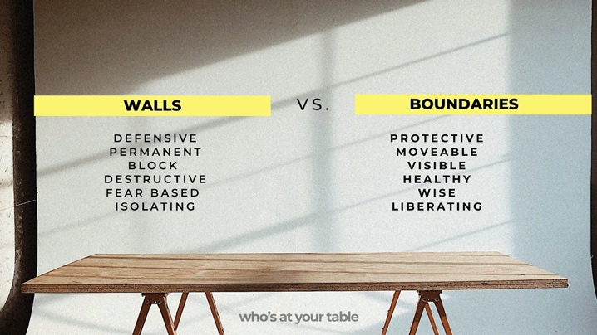

- Boundaries are meant to be healthy, and everyone should have boundaries
- Boundaries are healthy and they are not judgmental
- They represent lines that should not be crossed (i.e., certain topics can be off-line, not everything is on the table for discussion)
- They have visibility
- They can be moved and shifted as necessary—this can even include prophecy and how you allow people to speak into your life.

- The individual that put them up in place is not afraid to be seen.

- Jesus had boundaries for Himself
- God places boundaries (i.e., the forbidden tree in the Garden of Eden)

- Some examples of boundaries can be topics, women’s purses, phones
- We can be ourselves but not cause others to stumble.
- Even in the physical body, there are boundaries, the only thing that does not have any boundaries is blood.

- People can cross into our boundaries without even knowing it
- If you do not define boundaries, you have created new boundaries
- Capacity is very important when creating boundaries – some people cannot handle what is being said
- Ask yourself the question: How far can I go with people?
- Some people have an extreme attitude and will cut you off from their life
- How far can you go in discussions with people?
- Not everyone at your table can handle everything the same way
- People have different expectations.

- Do we ever think that people need protection from us?
- We may have harmful tendencies:
- We must restrain our tongue
- Some topics may be offline.

- Walls
- Are erected to keep people out - it is a negative concept
- It blocks people
- It distorts visibility.

- Not only keeps people out, but it keeps people in
- People put them up as a defence mechanism
- It creates a lack of vulnerability
- They are hard to take down
- They are usually permanent and absolute.

- Walls hinder restoration and reconciliation because they are fortified.

- They are put up to protect people from emotional hurt
- They are designed to stop invasion and emotional damage at all costs.

- In general, it isolates people

- Walls are unspoken but evident

- People with walls never fully trust

- God works to bring down our walls, we should not have them in the first place

- Walls are very difficult to get through.

- Illustration: Who’s plate would you not eat from?

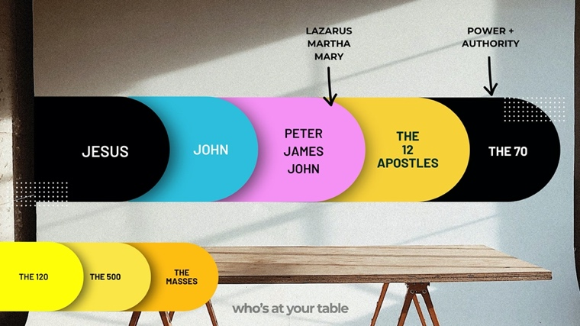

- It is dangerous when we make and take things personal – living at peace means not taking things personal
- People are on edge – waiting to take things personal – it robs us of our peace.

James 3:16-17
¹⁶ Whenever you're trying to look better than others or get the better of others, things fall apart, and everyone ends up at the others' throats. ¹⁷ Real wisdom, God's wisdom, begins with a holy life and is characterized by getting along with others. It is gentle and reasonable, overflowing with mercy and blessings, not hot one day and cold the next, not two-faced. (The Message)

These teachings emphasize the importance of love, unity, forgiveness, and mutual support in fostering healthy and thriving relationships within the Christian community and beyond.

QUOTES & STICKY STATEMENTS

Your table is full of people that are most likely like you.

Where relationships are lacking, more rules are required.

SERMON CONCLUSION - THE CALL TO ACTION

Sometimes our relationships are dysfunctional because we are dysfunctional within ourselves:
- High level of self-awareness and perception is required
- It does not have to be extreme behaviour or dysfunction
- We tend not to go to the person that will give us the God answer – “Wait till I tell so and so about this….”

