Be Fruitful And Multiply
The Multiplication Process: Part 4
January 29, 2023
Rev. Dr. Tony Soldano

SERMON DESCRIPTION

The secret sauce to multiplication is abiding in Christ. You are designed to produce fruit, more fruit, and much fruit.

CENTRAL TRUTH

The secret to significant and lasting fruit is “abiding” in Christ.

MAIN PASSAGE

I Am the True Vine

John 15:1-8
¹ “I am the true vine, and My Father is the vinedresser. ² Every branch in Me that does not bear fruit He takes away; and every branch that bears fruit He prunes, that it may bear more fruit. ³ You are already clean because of the word which I have spoken to you. ⁴ Abide in Me, and I in you. As the branch cannot bear fruit of itself, unless it abides in the vine, neither can you, unless you abide in Me. ⁵ “I am the vine, you are the branches. He who abides in Me, and I in him, bears much fruit; for without Me you can do nothing. ⁶ If anyone does not abide in Me, he is cast out as a branch and is withered; and they gather them and throw them into the fire, and they are burned. ⁷ If you abide in Me, and My words abide in you, you will ask what you desire, and it shall be done for you. ⁸ By this My Father is glorified, that you bear much fruit; so you will be My disciples.

TRANSITION STATEMENT

God takes being fruitful very seriously.

MAIN POINTS

Jesus describes four types of people within the teaching of John 15; they include those who bear:
- No fruit – useless or unfruitful
- Fruit – producing some fruit
- More fruit – the addition process
- Much fruit – the multiplication process

The Four Quadrants of Bearing/Not Bearing Fruit
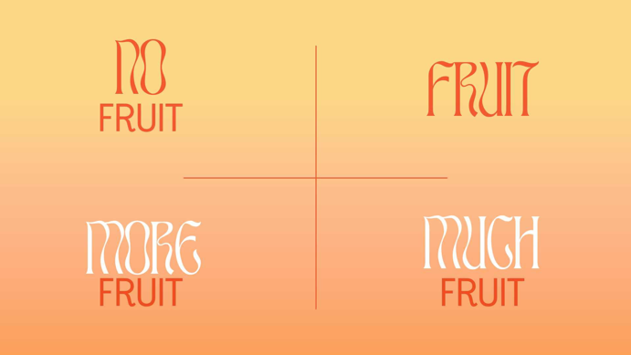

- Sequential order of the passage: “Abide”:

Perhaps there is a connection between the Parable of the Talents (i.e., 5-2-1-talents), the harvest in the Parable of the Sower (i.e., 30-60-100-fold) and John 15:1-8 (i.e., fruit, more fruit, and much fruit).

Matthew 13:23
But he who received seed on the good ground is he who hears the word and understands it, who indeed bears fruit and produces: some a hundredfold, some sixty, some thirty."

- No Fruit
  - How is it possible to be connected to Christ and yet bear no fruit?
- False believers
- Believers in name only
- Having a form of godliness but denying the power there of.

  - The Father removes them and casts them out into the fire
- Fruitless branches wither up and die because they are NOT connected to the source – Christ
- They are gathered and cast into the fire and burned up.

  - It is a source of anger to the Lord
- i.e., the fig tree and no fruit.

  - I am the true vine
- Israel Old Testament vine failed to produce fruit (Isaiah 5:1-7)
- Jesus replaces Israel as the central focus of God’s plan of salvation – the nations will not be blessed through a people but through Jesus
- The Father/vinedresser desires fruit.

  - Additional passages:
- Ephesians 5:11
And have no fellowship with the unfruitful works of darkness, but rather expose them.
- 2Peter 1:8
For if these things are yours and abound, you will be neither barren nor unfruitful in the knowledge of our Lord Jesus Christ.

- Fruit
  - The greatest and most significant fruit that can be produced in our life is the fruit of Holy Spirit
- Ephesians 5:9-10
… (for the fruit of the Spirit is in all goodness, righteousness, and truth), ¹⁰ finding out what is acceptable to the Lord.
- Galatians 5:22
But the fruit of the Spirit is love, joy, peace, longsuffering, kindness, goodness, faithfulness,
²³ gentleness, self-control. Against such there is no law. ²⁴ And those who are Christ's have crucified the flesh with its passions and desires.

  - Any fruit that bears fruit is pruned
- Pruning – the idea of trimming, cutting back and removing dead or overgrown branches and stems to produce more fruit
- The idea of pruning is to cut back.

  - To make clean
- We are made clean by the word of the Lord.

  - The fruit cannot bear on its own
- We are required to be connected to Christ
- The purpose of the vine is to provide life, nourishment and sustain power.

- More Fruit
  - The process of “more fruit” is achieved in two ways:
- Pruning
- Being made clean - the disciples have been made pure/guiltless because of the logos of Jesus. God’s Word is the ultimate means of grace.

  - More fruit process of being cleansed and pruned, without this process, you cannot become more fruitful.

  - Abiding must be continuous – branches cannot bear fruit by themselves; they cannot sustain themselves. Dual flow of abiding. Branch is connected to the vine; the vine is connected to the branch.
- Old Testament system does not work – we need Christ
- Old Testament shows us our failure when we continue to try to do things on our own and in our own strength. No Old Testament sacrifice was enough – it is never enough
- Combination: Abiding in Christ + Christ abiding in me = bearing fruit.

  - We become fruitful in two ways
- We are made “just” by the Word of the Lord
- We are pruned – which means to cut back
- The pruning process may look like we are taking a step back
- The Father removes the branches that do not produce fruit. He prunes the branches that are producing fruit so that they may produce more fruit. What is pruning?
- Spring pruning
- To prune - to clean; purify
- Play on words with vs 2-3 “you are already clean because of the word I have spoken to you”
- It is not enough to be cleansed - abiding must take place to bear fruit
- The correct response to the Word is fruitfulness
- Romans 5:3-5; James 1:2-4.

- Much fruit
  - The secret to the life of Jesus was that He desired to reveal and glorify the Father. Everything He said, and accomplished was with this goal in mind, to bring glory to His Father, and to shine light on His amazing love and character.

  - The result of pruning ultimately leads to an abundance of fruit – much fruit
- Perhaps this the 100-fold or
- The five talents.

  - The Father is glorified when we bear MUCH fruit.

  - The much fruit is the process of multiplication.

  - The key to having our prayers answered is to abide in Christ
- However, when we abide our desires will change, our prayer request will change and they will line up with the Word and will of God

  - The branch can do nothing apart from the vine. Is this to say we cannot live life? No, but this is to say that everything we do will have ZERO value. It will all be meaningless.
  - The purpose of the branch is to abide to bear fruit. ONE thing in this passage glorifies God - that you bear fruit.
  - This means you cannot glorify God if you are not abiding in Christ – and if you are not glorifying God, you can be doing everything and yet NOTHING.

QUOTES & STICKY STATEMENTS

The secret sauce of being fruitful and multiply - abide in Christ.
Blessed: Empowered to prosper.
Subdue: exercise your authority.
I am the True Vine ~Jesus
The Father is the Gardener, Jesus is the Vine, we are the branches.
You're here to abide and the fruit will be produced.
If you abide then naturally you're going to bear fruit.
Through that pruning process God does not want to hold us back but to shoot us forward.
You cannot abide through someone else's connection.

DISCUSSION QUESTIONS

- What quadrant would you say you are in currently: no fruit, fruit, more fruit and much fruit?

- What is your definition of abiding? How do you actively abide daily?

- Discuss how it is possible to be a branch in Christ and not bear fruit.

- Discuss Jesus as the true vine vs. Israel as the vine. What difference does this make?

- Do you believe that we can ask whatever we desire and that we will receive it?

- Discuss how Christ abides within the life of the believer.

- Discuss the following features that occur at much fruit:
- The Father is glorified
- Prayers are answered
- You will be called the disciple of Christ.

