Think Again: Developing A Healthy Mind – Part 3

Smashing Strongholds: Part 1
March 20, 2022
Rev. Dr. Tony Soldano (Pages 1-8)
Ranjeev Dutt (Pages 9-13)

CENTRAL TRUTH

As Christ followers we are called to destroy, smash, and pull down every high and lofty argument that arises in our mind against the knowledge of Christ. The source of our thoughts require discernment and must be challenged and weighed. If we are going to have a healthy and strong thought life, it is necessary to take inventory of what occupies our mind. For example, if a thought brings the believer into submission to Christ and His will, then this is a good, healthy, and positive thought. On the contrary, if a thought brings the believer into rebellion and disobedience, then such a thought must be brought into captivity and ultimately demolished. In other words, every thought, positive or negative, must come under the authority of Christ Jesus.

SERMON DESCRIPTION

Through the powerful weapons that God has provided, you are well equipped to destroy strongholds (arguments) that may be residing within your mind.

SERMON QUESTIONS

- What do they need to know?
- Strongholds are arguments in the mind that need to be torn down.

- Why do they need to know it?
- Strongholds that are ignored only become stronger and imprison the believer to greater depths.

- How should we apply it?
- We must utilize the mind of Christ to tear down strongholds in the mind.

OPENING LINE

No one can destroy the thoughts that are in your mind, only you can accomplish this, and God has given you the power and ability to accomplish it.

MAIN PASSAGE

2Corinthians 10:3-7
³ For though we walk in the flesh, we do not war according to the flesh. ⁴ For the weapons of our warfare are not carnal but mighty in God for pulling down strongholds, ⁵ casting down arguments and every high thing that exalts itself against the knowledge of God, bringing every thought into captivity to the obedience of Christ, ⁶ and being ready to punish all disobedience when your obedience is fulfilled.
⁷ Do you look at things according to the outward appearance? If anyone is convinced in himself that he is Christ’s, let him again consider this in himself, that just as he is Christ’s, even so we are Christ’s.

MAIN POINTS

Observations From the Passage

- What is “the knowledge of Christ”?

Paul’s teaching clearly communicates that there is nothing greater than knowing Christ. Strictly speaking, no accomplishment could ever compare to a personal relationship with Christ Jesus. In fact, he indicates that everything else is dung and useless, that Christ is all, fills all, and will be all—He is all satisfying, He is perfection, He is glory, He is excellent, He is awesome. What can compare to Him? Nothing! Paul communicates that Christ fills all and satisfies the deep longings of the soul, that He is more than enough and that nothing could ever take the place of Jesus within the life of the believer. To make such statements requires a true knowing of Him—this will be useless to the person that does not know Christ. It is as foolishness to that individual, but you are the one that knows Him—it is the very essence of life.

The knowledge of Christ is:
- To know Him and His Excellency
- What is “bigger and better”.

Question: Why are people not figuring out that Christ is more than enough and that He surpasses all things?

The excellency of the knowledge Christ:
- Christ is superior to all and everything
- People have a shallow level of knowledge, but they are trying to tear down strongholds – this is impossible
- When we truly know Christ, it is natural to love Him
- Every argument and high thing (a strong tower) must submit to the superior knowledge of Christ.

Philippians 3:8
Yet indeed I also count all things loss for the excellence of the knowledge of Christ Jesus my Lord, for whom I have suffered the loss of all things, and count them as rubbish, that I may gain Christ.

Commentaries

“The excellency of the knowledge of Christ - That superior light, information, and blessedness which come through the Gospel of Jesus Christ; justification through his blood, sanctification by his Spirit, and eternal glory through his merits and intercession. These are the blessings held out to us by the Gospel, of which, and the law, Jesus Christ is the sum and substance”.
~Adam Clarke

“In coming to Christ for salvation, Paul had renounced all things and counted them worthless when compared to the excellence of the knowledge of Christ Jesus, his Lord. The excellence of the knowledge is a Hebrew way of saying “the excellent knowledge” or “the surpassing worth of knowing.” Ancestry, nationality, culture, prestige, education, religion, personal attainments—all these the apostle abandoned as grounds for boasting. Indeed, he counted them as dung or rubbish in order that he might gain Christ”. ~Believers Bible

- What is a stronghold?

The word stronghold is only used once in the entire New Testament. Paul uses an illustration from the Old Testament, which normally was used in a positive sense, that strongholds protected God’s people from attack. However, in the New Testament, Paul uses the word to demonstrate that it can become a prison. According to Paul’s teaching, they are erected and fortified within the “mind”.

- Strongholds are “arguments” that stand against the knowledge and authority of Christ (usually it is a false idea or thought) and they:
- Are high and lofty thoughts that tower over you
- Are intimidating
- Easily overwhelm and overpower a person
- Are strong and are meant to withstand invasion and assault, but in this case, they are working against you and resisting the truth
- Strongholds can easily become idols within the heart
- They resist or stand against the plans and purposes of God.

- It is a pattern of thinking that gets deeper, stronger, and higher overtime. Consider some biblical examples:
- The children of Israel developed “a grasshopper mentality” instead of believing in God and inheriting the promised land
- At the Last Supper, Peter could just not believe/accept that he would deny Christ
- Before his conversion, Paul really believed that he was doing God a favour by arresting and killing Christians – he truly believed that Christians were the problem
- Jesus said, “Your traditions” (strongholds) make the Word of God to no effect.

- They are ingrained/fortified in people – they become like concrete cinderblocks within the mind, sort to speak.

- They are cycles and patterns that continuously repeat themselves over time and seasons

- They are repeated thoughts that eventually result in behaviours and actions that you will live out

NOTE: Strongholds are NOT demons; however, the demonic realm will certainly take advantage of any existing stronghold and use it against the believer in Christ.

- The demonic realm can plant the seeds of strongholds

- When we yield our “members” (any part of our body) we open ourselves to demonic activity

- By rule, strongholds need to be torn down and not cast out. Christians can covenant themselves with “belief systems” – this is where demons come in and exploit people. For example, some of the things that people believe and say:
- I am cursed
- No one likes me
- No one desires me
- Everyone avoids me
- My people group is victimized
- Nothing ever goes right for me – it never works out
- I’m inferior
- My children are terrible
- My marriage is over
- I will never get ahead in life
- I will never amount to anything
- As a man thinks in his heart…

- How do we tear down strongholds?

Only the mind of Christ (the cognitive side) can bring down strongholds because it is established in the truth and the love of God with all its soul, strength, and mind. They need to be identified and destroyed, by pulling them down from the top to the bottom.

- Through spiritual warfare
- Paul informs the believer in Christ that God has provided mighty and powerful weapons of spiritual warfare that are not only essential but are able to tear down strongholds. This is not a natural fight but a spiritual fight, in fact it is a war, and sometimes even to the death. However, spiritual warfare has more to do with wisdom and strategy than just shouting at demons. Whether we like it or not, or want to accept it or not, we are in a spiritual war! It requires:
- Wisdom and discernment
- Self-control and discipline
- The ability to love God with your “mind” (this means that we need to understand how we love God and not just have affection for Him)

- In biblical and medieval times, high towers and strongholds were defeated by casting large boulders and/or metal cannon balls at them. It required a catapult to generate the amount of torque required to hurl these large objects to destroy the fortified walls. This gives us a sense of the might that is required to destroy these high and lofty castles.

- Truth and confrontation
- In order for an argument to be destroyed and brought down it requires a counter argument— it requires the truth. There are times when we need to be confronted by the reality of the truth that is grounded in God’s word. Consider:

- The teachings of Jesus infuse the truth or the counter argument, He interjects a different/opposing argument in the scenario

- At times, our vision and perspective can become completely blurred and we require someone to come and clean our lens for us. For example, King David needed Nathan the prophet to confront him and to provide him with clear thinking and unblurred vision when it came to his sin with Bathsheba because he was in a state of deception. He did not even realize that he was in the wrong, but he had sinned against God and was completely caught up in his own behavior. He was blinded by his lust.

- David lacked clarity – he needed the prophetic ministry of Nathan to open his eyes and confront him. David lacked self-awareness and could not see himself for who he really was and what he had done. Therefore, God had to appeal to David’s sense of justice. In some ways God had to slap him in the face and trick him into doing the right thing and to the realization of what he had done.

- Although David’s relationship with God was not perfect at least it was intact and it mattered to David how he related to God. Therefore, when he came to his senses he repented.

- Paul is another example. Jesus had to confront him, blind him, and throw him off his high horse in order for truth and light to come into his life.

We condition ourselves to “win” the argument—this is human nature. If we are not careful, we will defend ourselves to a fault and to our very own detriment. Therefore, we require clarity, and we must ask the question: Is it me, or is everyone else at fault? It is interesting that there are certain matters everyone else sees about us, but we do not. Who is delusional? Everyone else or you? We need the grace of God and/or others to help us confront our own hearts and minds at times.

Truth provides:
- Perspective and accuracy
- The big picture
- Destroys false paradigms
- Causes an individual to let go of control and trust God
- When the truth moves from our head to our hearts, faith begins to engage, and the argument is removed.

- Root issues must be dealt with and removed
- Life and strength are always found in the root of the matter. To put it another way, the fruit is in the root. These are core and fundamental issues that must be addressed to realize freedom and liberty in Christ. Consider some critical roots:
- Fear
- Betrayal
- Insecurity
- Rejection.

- The truth identifies and digs out root issues from our lives. Removing the root issue will prevent future negative outcomes.

- Unfortunately, root issues may take a long time to manifest. They may appear later in life, after people have experienced traumatic events or life altering trauma.

- Self-talk: accurate perspective that is based on the truth
- Everyone experiences self-talk, both negative and positive; however, it has been proven that most self-talk is negative. This is where the counter argument can be a powerful weapon in destroying strongholds. Christ followers must possess the ability to speak to their own mind and thoughts and to subjugate those that are negative and adversarial to Christ. No one can do this for you, it is a discipline that must be developed, and it is a muscle that must be strengthened. Unfortunately, most self-talk is typically negative, debasing, and rooted in fear and insecurity.
- You can have a good heart but a distorted mind, your intentions might be correct but because of the thoughts in your mind, your words, and your actions, can come out completely wrong. Therefore, people can appear successful but have horrible lives.

- Fallback excuses – to save face or explain actions and behaviours people have excuses and things that they fall back on. Consider some things people use as excuses:
- God knows my heart
- I am a good person
- This is who I am, accept it
- This is how I have always been
- That was not my intention
- This is all I know
- No one ever thought of me differently
- I have been through so much in my life
- I never get a break
- No one understands me
- Get used to it.

- Strengthen yourself in the Lord – King David
- In one of the most difficult times in King David’s life he had to learn how to encourage himself in the Lord because everyone had turned against him and wanted to kill him. David had to fortify his mind, reject the negative narrative, and create a counter argument for his soul, otherwise he would have literally lost his life.

- Talk yourself out of the strongholds you believe. Consider some of these key actions:
- It may not be real
- You may need to unlearn some things
- Quiet down your emotions
- Speak truth
- Speak possibilities
- Find the truth – do your due diligence.

- Peace that surpasses understanding
- You think yourself to peace – the cognitive side of the mind of Christ.

- Paul said, “think on these things”, and “set your mind on”. The believer has a responsibility over their own thought process and to ensure that it is focussed on the things that are above and not beneath:
- Philippians 3:15
- Colossians 3:2
- Philippians 4:7.

- Thoughts precede peace; therefore, you must think the right things to experience the peace of God and with God.

- Think critically about peace that is grounded in God’s truth
- The peace of God is beyond our understanding

- The grace of God kicks in at some point because we are “thinking on these things”. We do our part/the right thing and God does the rest

- Repeated thinking makes things concrete in our mind. This can be both positive and negative and we begin to truly believe and act upon these thoughts. For example, some people can think themselves to be sick.

- The “bigger and better principle”

This principle is about setting your focus on something that is superior to what you are arguing with and/or you are going to lose. Christ is always superior! This can also be called, “The Displacement Theory" where a stronghold needs to be displaced by something that is weightier.

- We tear down arguments through Christ because He is bigger, better, stronger, and able.

- When you are going through a trial you must find something bigger and better to put your attention. Specifically, you must replace it with something of greater value/worth or something you love more.

- For example, Joseph resisted the sexual advances of Mrs. Potiphar because he believed there was a greater purpose for his life.

- Esau, however, did the exact opposite. He sold his birthright for a pot of stew. He could not see that anything was more important to him at that moment. His belly was all he cared about and treated the things of God as common.

- Correction and discipline (Jesus rebukes Peter)
There are occasions when we require correction and discipline, either from God or from those who are given spiritual oversight over our souls.

- Peter rebuked Jesus for talking about His death and going to the cross. Jesus had to correct him and bring the right perspective of God’s plan and purpose to his life. Perhaps Peter was still riding high from the fact that he was given revelation as to the identity of Christ. Clearly, a stronghold began to formulate in his mind regarding his own self-evaluation and his relationship with Jesus. Peter thought that he was doing a good thing by taking Jesus to task and trying to “protect Him” (Matthew 16:21-23).

Consider some observations of the passage:
- “Get behind me Satan” (i.e., the “adversary”) you are standing against what I am trying to accomplish
- “You mind the things of men” – connection between the demonic and the natural man – human thinking and reasoning
- Jesus was speaking to both Satan and Peter – there is a duality of conversation
- Jesus addresses Satan but also speaks to Peter
- Jesus surveys how the other disciples are being impacted and He addresses the stronghold in Peter’s mind
- Clarity – this was not a one-time rebuke. Jesus was teaching Peter that when you hear this voice in your head you know it is the enemy. Jesus does Peter a favour by bringing clarity for the rest of his life
- The devil always needs a voice and a body to express his idea and establish his strongholds, therefore he is hard at work to infiltrate the thought life of God’s people.

    - Peter required many adjustments in his life
- At the Last Supper – Peter strongly resisted the idea that he would deny Christ even though the Lord Himself told him
- Paul withstood Peter to the face in the Book of Galatians because Peter was operating in hypocrisy - even Barnabas was caught up in it and was influenced by Peter
- With Cornelius – Jesus had to communicate to him that what he had made clean should not be called common.
- Peter had a stronghold of racism in his life

    - We need to be corrected with the truth. When Peter wrote his Epistle, he indicated that we need to, “gird up the loins of our mind”

1 Peter 1:13
Therefore gird up the loins of your mind, be sober, and rest your hope fully upon the grace that is to be brought to you at the revelation of Jesus Christ;

- What does “to the obedience of Christ” mean?

The fundamental concept is that ideas and arguments are not allowed to run rampant and wild within the soul. They need to be brought in, controlled, thrown out and evicted. If Christ is the warden and you are the prison keeper, arguments become jailed and imprisoned rather than them imprisoning you. Therefore, someone needs to be in charge, and it will either be the arguments of your mind or the knowledge of Christ.

    - Every thought that does not comply with the mind of Christ needs to be brought into captivity or slavery—it is essential that it be brought under a superior thought and/or power.

    - Our mind needs to be fully engaged and intentional about taking prisoners of war, so to speak

    - Every thought needs to be brought into subjection to the truth of God’s Word

    - Ideas need to be identified and the source recognized.

- What are examples of strongholds in the mind?
- Sexual addictions
- The notion that women are sex objects
- Racist thoughts
- Philosophies
- False belief systems
- False worship/idolatry.

QUESTIONS & DISCUSSION

- Expand on the idea that, “thinking precedes peace”. What does this look like practically and in real life?

- Why did Peter have to be adjusted so many times particularly in his thinking?

- Discuss the concept that, ‘the satanic and humanity are on the same wavelength of thinking and always opposing God’s purposes and plans’.

- List five potential strongholds that people can have in their mind.

- Before his conversion, Paul had a stronghold in his mind concerning Christians. What was it? Why was it there? How was it removed? Review the passage of his conversion in the Book of Acts.

- Is every belief system necessarily a stronghold? Why or why not?

- Peter teaches us that we need to “gird up the loins of our mind”. What does this mean to you?

- Why is the mind considered a battleground? Why are we at war in our minds? Why are people experiencing turmoil within their life?

- How can a Christian set their mind on heavenly things and not allow their thoughts and ideas to run wild?

Think Again: Developing A Healthy Mind – Part 3

Smashing Strongholds: Part 1
March 20, 2022
Ranjeev Dutt

A HEALTHY MIND

2Corinthians 10:1-7
¹ Now I Paul myself beseech you by the meekness and gentleness of Christ, who in presence am base among you, but being absent am bold toward you: ² But I beseech you, that I may not be bold when I am present with that confidence, wherewith I think to be bold against some, which think of us as if we walked according to the flesh. ³ For though we walk in the flesh, we do not war after the flesh:
⁴ (For the weapons of our warfare are not carnal, but mighty through God to the pulling down of strong holds;) ⁵ Casting down imaginations, and every high thing that exalted itself against the knowledge of God and bringing into captivity every thought to the obedience of Christ. ⁶ And having in a readiness to revenge all disobedience, when your obedience is fulfilled. ⁷ Do ye look on things after the outward appearance? if any man trust to himself that he is Christ's, let him of himself think this again, that, as he is Christ's, even so are we Christ's.

WE WAR (IN OUR MIND)

The war is not in the flesh even though we walk in the flesh. Then where, is it? We wrestle against:
- Principalities
- Powers
- Rulers of darkness of this world
- Spiritual wickedness in high places.

Ephesians 6:12
¹² For we do not wrestle against flesh and blood, but against principalities, against powers, against the rulers of the darkness of this age, against spiritual hosts of wickedness in the heavenly places.

War On the Mind
We do not war after the flesh.
- Not carnal wars but spiritual ones
- Wars of imagination and arguments
- Wars of high and haughty attitudes
- Wars, not of enemy soldiers, but of enemy thoughts.

2Corinthians 10: 3
³ For though we walk in the flesh, we do not war according to the flesh.

- Our mind is so powerful that it can shape our perception of reality. This is where the saying, “worried to death” comes from.

- The battlefield of the Mind
Proverbs 23:7
For as he thinks in his heart, so is he.

- Story of man locked in a cold truck.

- Sometimes our biggest enemy is ourselves
- We create conversations, scenarios, and arguments within ourselves
- We are upset with someone, and we make up arguments and conversations. We are ready to fight and not ready to listen and sometimes for the smallest, silliest reasons
- Being mad because of a dream (example of Keesha dream)
- We entertain imaginations that feed into the appetite of the flesh
- Even in the workplace we can war with our mind because we over analyze everything (Paralysis by analysis)
- If we are not careful, we risk the danger of allowing a stronghold to be created.

WHAT IS A STRONGHOLD OF THE MIND?

Definition:
- Ochryoma - in the positive sense, a place that is fortified, castle, fortress, protected (Jesus is our stronghold)
- There is a “strong” “hold” = “powerful” “grasp”
- In the negative sense and in this context, it can be likened to a prison.

Impact of a Stronghold – The Domino Effect
- Strongholds move from the mind to the heart
- Once in the heart it becomes part of your speech
- Once part of your speech it then hits the power of your tongue
- Which can then create actions
- Which creates habits
- Which starts to form character that is then passed to the next generation.
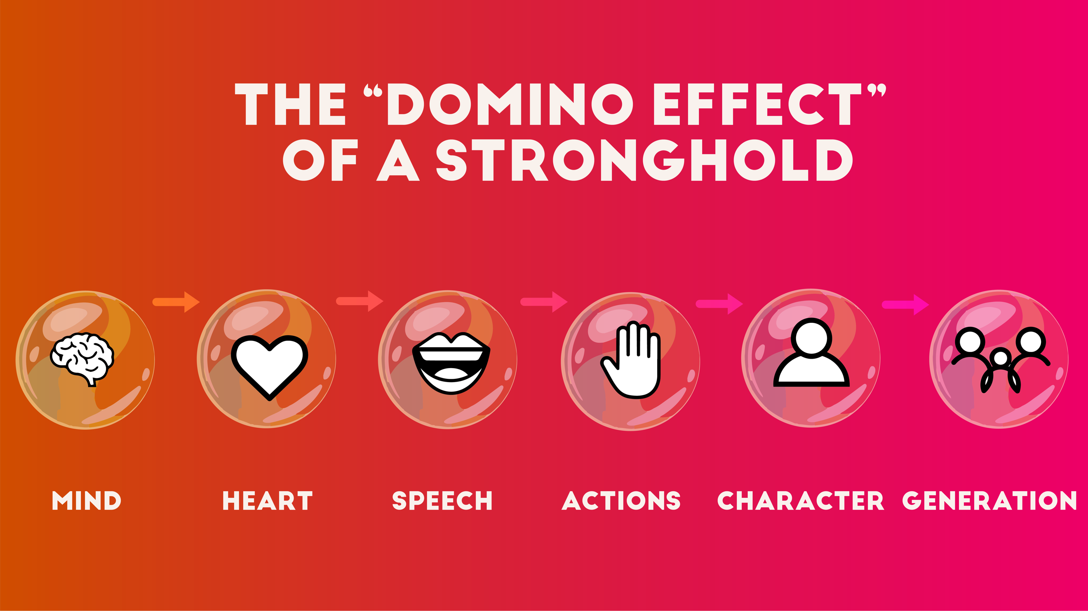
- Rinse and Repeat.

How Are They Developed?
- When we allow thoughts to develop that are contrary to the Word and Kingdom of God.
- Constant replaying in our mind of an issue or something negative. Arguments are a large source of strongholds that are created.
- We have not spent time to protect our mind. We have allowed people to trespass and live in our minds rent free. We need to start evicting them.
- Feeding into habits and behaviors we know are contrary to our walk.
- We are not governed by the Word, but rather our own “truth”.
- When our mind is not continually renewed by the Word of God.
- Continue to put ourselves in an environment that messes with our mind.

Example of Strongholds of the Mind

Fear:
- Killer of a sound mind

2Timothy 1:7
God has not given us a spirit of fear, but a Spirit of power love and a SOUND MIND.

- Fear stops us from doing so many things. It is the fertilizer for strongholds.

Family/Culture:
- Mindsets that have been passed from generational thinking, actions, habits.
- The mindset that family comes before God has also become a stronghold.
Comfort:
- Our relentless pursuit of comfort, to not have to war, be isolated and away from problems.
- We are not called to be comfortable as believers.
- We strive for comfort at the expense of our purpose and call.

Time:
- We can get so caught up in our schedules. We are ruled by them at times and forsake God, and other important areas of our life because we put every aspect of our life on a timer.

Bitterness/Unforgiveness Gossip, Jealousy, Addition, Perfectionism, Ego, Money, etc.

The Worlds Approach:
- We develop these walls over time, and they become prisons. Unfortunately, we start to become comfortable and make homes in our prison.
- We are taught how to become comfortable in our misery versus how to smash them out of our life.

WEAPONS TO PROTECT OUR MIND

- Our Weapons are Mighty (doo-nat-os) – able, powerful, strong in soul (mind)

- Armour of God

Ephesians 6:13
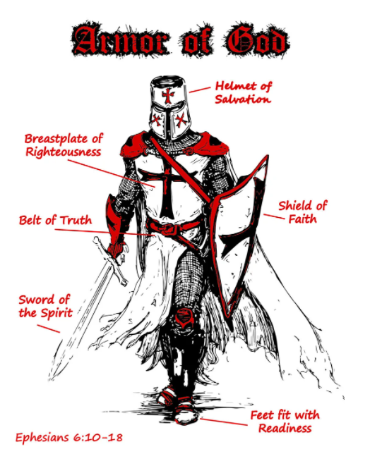
Therefore put on the full armor of God, so that when the day of evil comes, you may be able to stand your ground, and after you have done everything, to stand. ¹⁴ Stand firm then, with the belt of truth buckled around your waist, with the breastplate of righteousness in place, ¹⁵ and with your feet fitted with the readiness that comes from the gospel of peace. ¹⁶ In addition to all this, take up the shield of faith, with which you can extinguish all the flaming arrows of the evil one. ¹⁷ Take the helmet of salvation and the sword of the Spirit, which is the word of God.

Helmet of Salvation (A blow to the head could be an instant kill)
- Our minds are renewed
- Rejects doubts that come from circumstances
- Keeps an eternal perspective by having the mind of Christ
- Protects from forgetting victories.

- Our counter argument using the Word
- Our argument must be grounded in the truth
- Like a lawyer we must argue the case against the stronghold to ourselves
- To do that we must be prepared, by knowing what God says
- By evaluating what is true and not true.

Problem | Solution
If you are struggling with a stronghold of: | Surround it with:
Depression | Hope
Rejection | Acceptance from Abba
Unresolved anger | Forgiveness
Fear | The knowledge of God’s love
Failure | The victory of the resurrection

Once you have identified a stronghold, go to the Scriptures, and study the opposite truth from God.

https://www.lehigh.edu/~gdb0/simcha/strongho.htm#:~:text=Be%20honest%20before%20God%2C%20and,the%20instinct%20of%20defend%20yourself.

- Reminding ourselves that God is our stronghold
- The Lord is my light and my salvation; whom shall, I fear? The Lord is the stronghold of my life; of whom shall I be afraid? ~Psalm 27:1
- The salvation of the righteous is from the Lord; he is their stronghold in the time of trouble. ~Psalm 37:39
- But the Lord has become my stronghold, and my God the rock of my refuge. ~Psalm 94:22
- He is my steadfast love and my fortress, my stronghold and my deliverer, my shield and he in whom I take refuge, who subdues peoples under me. ~Psalm 144:2
- The way of the Lord is a stronghold to the blameless, but destruction to evildoers. ~Proverbs 10:29

- Prayer
- Ephesians 6:18 - And pray in the Spirit on all occasions with all kinds of prayers and requests. With this in mind, be alert and always keep on praying for all the Lord’s people.
- Instead of having conversations with yourself, have conversations with God, talk to the Holy Spirit and ask Him to help. Create this as a new habit in your life.

- Praise
- Weapons (Hop-lon) – any tool used for warfare, an instrument
- Joshua and the walls of Jericho - they surrounded the walls that kept them from the promise of God. They waited and were patient, they were obedient to the word of God and at the right time they lifted their shout which in turn shattered the walls that were before them.

HOW DO WE SMASH STRONGHOLDS?

Strongholds are not a casual thing. We need weapons because they need to be taken by force.

- These are thick walls, they are stubborn

- Some that have been built for years and some that are just formed

- We can SMASH strongholds buy pulling them down
- Cast down imaginations
- Brings exalted things that are against the knowledge of God down
- Captivity (taking control) of every thought to the obedience of Christ
- We need to change our thinking patterns
Philippians 4:8 - True, honest, just, pure, lovely, good report, virtuous, praiseworthy…THINK ON THOSE THINGS!

- Having Intentional preparation - 1Peter 1:13 “Gird up the Loins of the mind….”

Stronghold Evaluation Checklist
- Is it grounded in truth?
- Does it exalt itself (does it compete for my attention of the Knowledge of God)?
- Am I constantly thinking and focused on this argument?
- Is it effecting relationships around me?
- Does it cause me to want to isolate?
- Do I find reasons to want to feel this way?
- Do I not accept help?
- Can I receive a different perspective?

