Wisdom – Think About It
On The Daily – Part 2
November 14, 2021
Rev. Dr. Tony Soldano

Introduction

Be Wise! Your future depends on it. The secret of your success can be found in what you do daily. That’s right! Your future is predicated by what you consistently put in place every day. Literally, outcomes are determined by the source of your wisdom, the power of routine, the quality of your decisions and the people that you connect with.

Central Truth

The secret to your success lies in the wisdom that you apply, in your daily life.

Main Passage

1Kings 3:5-14
⁵ At Gibeon the Lord appeared to Solomon in a dream by night; and God said, “Ask! What shall I give you?” ⁶ And Solomon said: “You have shown great mercy to Your servant David my father, because he walked before You in truth, in righteousness, and in uprightness of heart with You; You have continued this great kindness for him, and You have given him a son to sit on his throne, as it is this day. ⁷ Now, O Lord my God, You have made Your servant king instead of my father David, but I am a little child; I do not know how to go out or come in. ⁸ And Your servant is in the midst of Your people whom You have chosen, a great people, too numerous to be numbered or counted. ⁹ Therefore give to Your servant an understanding heart to judge Your people, that I may discern between good and evil. For who is able to judge this great people of Yours?” ¹⁰ The speech pleased the Lord, that Solomon had asked this thing. ¹¹ Then God said to him: “Because you have asked this thing, and have not asked long life for yourself, nor have asked riches for yourself, nor have asked the life of your enemies, but have asked for yourself understanding to discern justice, ¹² behold, I have done according to your words; see, I have given you a wise and understanding heart, so that there has not been anyone like you before you, nor shall any like you arise after you. ¹³ And I have also given you what you have not asked: both riches and honor, so that there shall not be anyone like you among the kings all your days. ¹⁴ So if you walk in My ways, to keep My statutes and My commandments, as your father David walked, then I will lengthen your days.”

When was the last time you asked the Lord for wisdom in your prayer time?

Main Points

Your success and your future are predicated on what you do on a daily basis. People are always looking for the silver bullet—the big thing that will turn life around and make the greatest impact. But the reality is, it is actually in the little things, in the daily activity, in the everyday decisions that determine outcomes.

There are some things that we need to consider regarding our daily routine. Obviously, everything cannot be listed here; however, consider the following:

- Do NOT neglect THE SOURCE of wisdom – God!
  - First and foremost, we must seek the face of God and ask Him for wisdom. James writes that if anyone is lacking in this area they should inquire of the Lord, and the Lord will provide an abundance of wisdom.

  - In fact, we can have as much wisdom as we desire, there is an abundance! The Lord will overwhelm us with His wisdom—He is generous and gives liberally. In other words, He does not measure it out, it is overflowing.

  - In the New Testament, James encourages anyone that is lacking in wisdom to ask God, and He will give it abundantly and liberally and without limit.

James 1:5
If any of you lacks wisdom, let him ask of God, who gives to all liberally and without reproach, and it will be given to him.

James 1:6
But let him ask in faith, with no doubting, for he who doubts is like a wave of the sea driven and tossed by the wind.

  - Wisdom, should be as much part of our daily bread as anything else
- Ask for daily bread
- Come into God’s presence daily, make time within your day to think and strategize
- Invite Holy Spirit into your life, decisions, and activity.

  - Spiritually
- “I die daily” ~Paul
- “Pick up your cross daily and follow me” ~Jesus
- Daily they gathered, in prayer, broke bread, fellowship ~The Early Church
- Give Thanks!

- Do NOT underestimate the power of routine
  - Many Christians equate routine as a bad concept, but the truth is that routine is very powerful. The most successful and the most disciplined people have constant routines within their daily life.

  - In fact, they do not move to step two until step one has been completed. If we are honest with ourselves, we determine that it is not knowledge that we like but rather the wisdom of routine that reinforces positive behaviour within our lives.

  - Jesus lived by the principle of routine. There were things that were absolutely custom to Him that He did on a consistent and a regular basis.

Luke 4:16
So He came to Nazareth, where He had been brought up. And as His custom was, He went into the synagogue on the Sabbath day, and stood up to read.

  - Principles of daily wisdom
- Some of the most creative and productive people operate by routine
- Set your daily goal to be wise and understanding
- Observe your surroundings and learn from them
- Creativity is about routine – it is not about moments or aha moments – work on every single day- slaves to routine and habits
- The early church went into the temple daily
- STEP BY STEP – do not start step 2 until you complete step one, etc.

  - Six things that should be part of your daily routine
- Start with GOD – prayer, presence, the Word
- THINK – schedule and set time aside literally to do nothing but to think and strategize
- CLOSURE - Bring things to closure
- PLAN ahead – the next day, week, month, quarter
- LEARN - everyday - ask yourself: What did I learn today? What lessons will I take away from all that I experienced and observed?
- THANKS - Express thanks – eliminate complaining.

- The quality of your wisdom determines those who are attracted to you
  - PEOPLE and RELATIONSHIPS – part of our everyday routine involves encountering people and building relationships in one way or another. The level of our wisdom directly impacts those that are attracted and repelled from us.

  - 1Kings 10:23
- High quality, influential, and even leaders came from various places to listen to Solomon and his wisdom.
- 1Kings 10:23 - So King Solomon surpassed all the kings of the earth in riches and wisdom.
- 1Kings 10:24 - Now all the earth sought the presence of Solomon to hear his wisdom, which God had put in his heart.
- 1Kings 10:25 - Each man brought his present: articles of silver and gold, garments, armor, spices, horses, and mules, at a set rate year by year.

  - The wisdom level you are operating in determines outcomes
- Proverbs 11:14 - Without good direction, people lose their way; the more wise counsel you follow, the better your chances. (The Message Bible)
- Proverbs 18:1 - Whoever isolates himself seeks his own desire; he breaks out against all sound judgment. (ESV)

- The quality of your decisions determines outcomes
  - God provides us with wisdom so that the quality of our decisions will improve; which will ultimately greatly impact our lives both spiritually and naturally.

  - God provides wisdom to help His people make correct and healthy choices and decisions. ALL decisions must be rooted in God’s wisdom and God’s wisdom is found in Jesus Christ.

  - Wisdom is not some mystic, gut feel, pull things from the air attribute; people that are wise make sound decisions that are also based in diligence—on data, numbers, research, due diligence.

  - The decision-making quadrant
- King Solomon was in each and every quadrant during the span of his lifetime and reign.
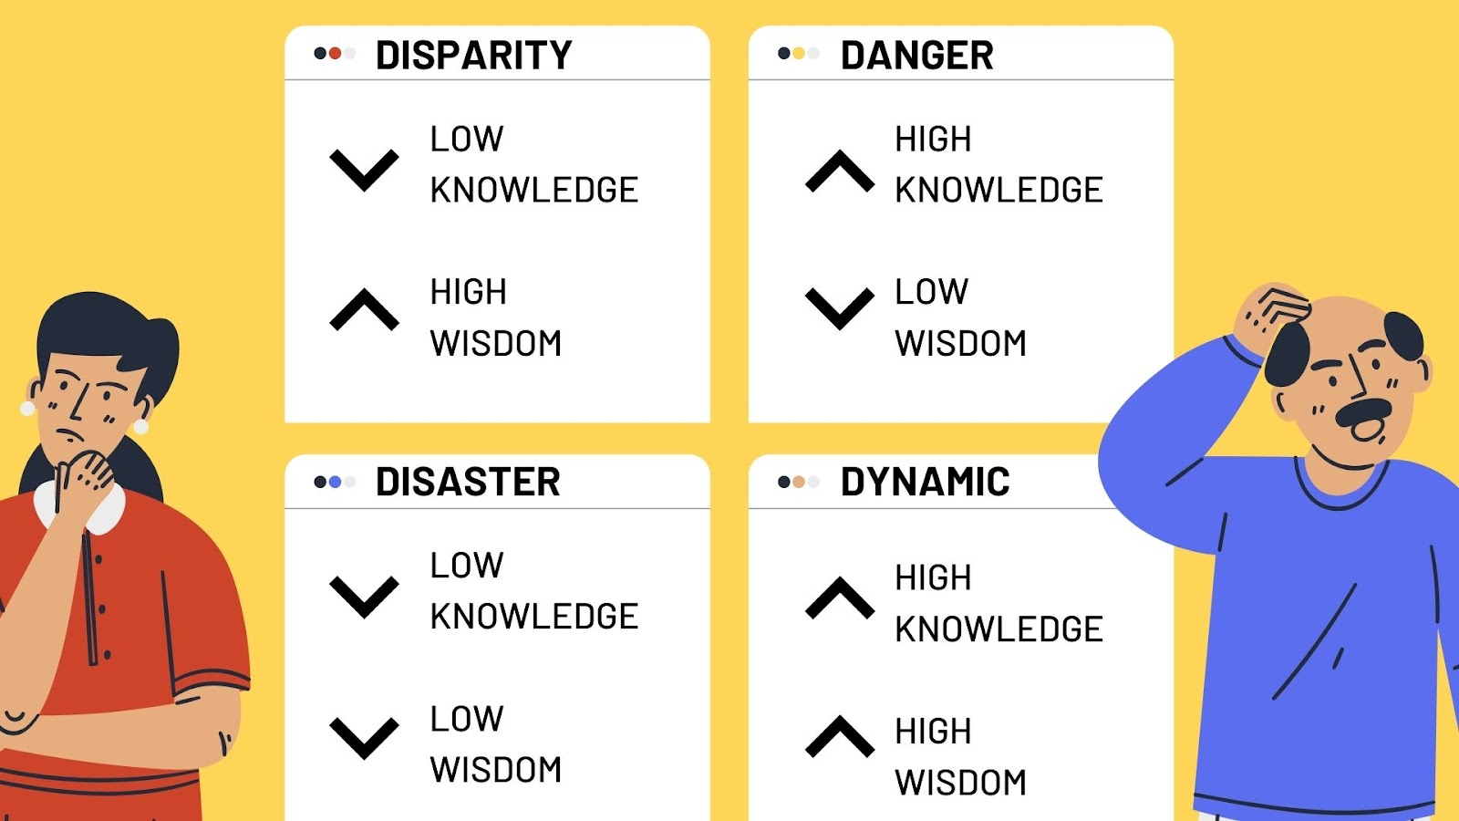

  - LEADERS - Stop making so many decisions
- The average adult makes 35,000 decisions a day
- Leaders are suffering from “decision exhaustion”
- Allow some team members to figure things out
- Think about your decisions: what really matters, what really requires your time and energy
- Delegate – you must do this in order to go to the next level.

  - Wisdom is the key that opens God’s treasures chest
- Colossians 2:3 - In him lie hidden all the treasures of wisdom and knowledge.
- Problem solving abilities
- Proverbs 3:5-7 – ⁵ Trust in the LORD with all your heart And lean not on your own understanding; ⁶ In all your ways acknowledge Him, And He shall direct your paths.
⁷ Do not be wise in your own eyes; Fear the LORD and depart from

Quotes

“Come to the source of all wisdom – God”.

“Wise decisions lead to prosperity as unwise decisions lead to ruin”.

“The decisions of the unwise become their calamity”.

“Wisdom breaks mind blockages”.

“The choices that wise people make releases confidence and confidence yields rewards”.

“The wise are remembered even after they are gone, the foolish are quickly forgotten”.

“Wisdom belongs to the disciplined”.

“Godly wisdom makes you humble”.

Conclusion

The truth will set you free; wisdom keeps you free.

King Solomon Becomes Foolish

1Kings 11:4
For it was so, when Solomon was old, that his wives turned his heart after other gods; and his heart was not loyal to the LORD his God, as was the heart of his father David.

John 8:32
And you shall know the truth, and the truth shall make you free."

Group Questions & Discussion

- List five things that you do daily.

- In the decision-making quadrant, which quadrant would you say you are in currently? How could you move into the next quadrant?

- What level of wisdom would you require in order to attract a higher quality of people into your influence?

- How was King Solomon’s heart drawn away from the Lord? What can we learn from this?

- What is “decisions fatigue”? What can you put in place to stop making so many decisions on a daily basis?

- Explain what Paul means when he says that the wisdom of God is in Christ Jesus.

- List five things that you do on a daily basis that adds to your wisdom.

- Explain how you implement the “power of routine” in your daily activity.

- Describe a foolish decision that you made. How did it cost you?

- Discuss and unpack Colossians 2:3.

