The Life of Joseph: When Life Loses Its Colour

When Life Forgets You - Part 3
August 8, 2021
Rev. Dr. Tony Soldano

Sermon Description

When life seems to forget you, you need to remember five critical aspects. Despite the many setbacks in Joseph’s life, God was with him. In the end, God’s purpose came to pass, and Joseph achieved his full potential.

Main Passage

Philippians 1:6
…being confident of this very thing, that He who has begun a good work in you will complete it until the day of Jesus Christ; …

Genesis 39:22
²² And the keeper of the prison committed to Joseph's hand all the prisoners who were in the prison; whatever they did there, it was his doing. ²² The keeper of the prison did not look into anything that was under Joseph's authority, because the LORD was with him; and whatever he did, the LORD made it prosper.

Joseph Interprets Two Prisoners' Dreams

Genesis 40:1 - 8
¹ It came to pass after these things that the butler and the baker of the king of Egypt offended their lord, the king of Egypt. ² And Pharaoh was angry with his two officers, the chief butler and the chief baker.
³ So he put them in custody in the house of the captain of the guard, in the prison, the place where Joseph was confined. ⁴ And the captain of the guard charged Joseph with them, and he served them; so they were in custody for a while. ⁵ Then the butler and the baker of the king of Egypt, who were confined in the prison, had a dream, both of them, each man's dream in one night and each man's dream with its own interpretation. ⁶ And Joseph came in to them in the morning and looked at them, and saw that they were sad. ⁷ So he asked Pharaoh's officers who were with him in the custody of his lord's house, saying, "Why do you look so sad today?" ⁸ And they said to him, "We each have had a dream, and there is no interpreter of it." So Joseph said to them, "Do not interpretations belong to God? Tell them to me, please."

Genesis 40:13-23
¹³ Now within three days Pharaoh will lift up your head and restore you to your place, and you will put Pharaoh's cup in his hand according to the former manner, when you were his butler. ¹⁴ But remember me when it is well with you, and please show kindness to me; make mention of me to Pharaoh, and get me out of this house. ¹⁵ For indeed I was stolen away from the land of the Hebrews; and also I have done nothing here that they should put me into the dungeon."

Genesis 40:21-23
²¹ Then he restored the chief butler to his butlership again, and he placed the cup in Pharaoh's hand.
²² But he hanged the chief baker, as Joseph had interpreted to them. ²³ Yet the chief butler did not remember Joseph but forgot him.

Life Stages

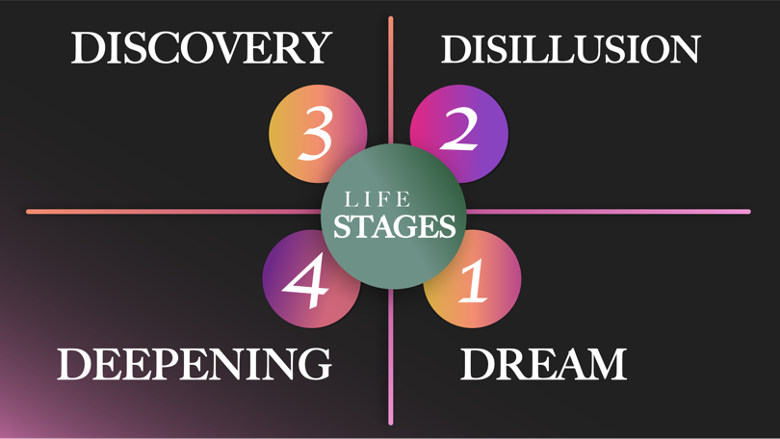

Life moves in cycles:

- The Dream
  - The dream that God gives you
  - The dream that is in your life
  - The dream that drives and propels you
  - The dream that is inside you that pulls you forward.

- The Disillusion
  - In this season/stage of life you can experience:
- The idea of discouragement
- Despair
- Confusion and questioning
- Despondency
- The place of testing
- Many questions arise – faith can be doubted
  - The enemy loves to torment and mock you in this stage – he will even question God’s character.

- The Discovery
  - Revelation - Revelation that comes from Father
- Who you are
- Your purpose
  - Learning
  - Re-define who you are
  - Re-invent yourself
  - Knowledge of God - knowing is spiritual.

Ephesians 1:18
The eyes of your understanding being enlightened; that you may know what is the hope of His calling, what are the riches of the glory of His inheritance in the saints,

- The Deepening
  - Deep growth in:
- God
- Disciplines
  - Being established
  - Putting down roots.

1Peter 5:10
But may the God of all grace, who called us to His eternal glory by Christ Jesus, after you have suffered a while, perfect, establish, strengthen, and settle you.

Stages of Learning

- Unconscious Incompetence: You lack the knowledge or skill, but you are unaware. The individual does not recognize or have knowledge on how to do something and does not necessarily know their weaknesses. This outcome might be a denial of behavior of the usefulness of the skills.

- Conscious Incompetence: You lack the knowledge or skill, but you are aware. They may deny the usefulness of the skill. The individual must recognize their own incompetence, and the value of the new skill, before moving onto the next stage.

- Conscious Competence: You have the knowledge or skill but must focus. The individual understands or has knowledge on how the task should be done. Demonstrating the capacity or competence that is required to focus. It may be broken down into phases; however, the increase of consciousness and the new abilities of skills increase with time.

- Unconscious Competence: You can perform the skills automatically, even with your eyes closed. The individual has severe practice with a skill that has become second nature. As a result of this, the skill can be performed while executing another task.

Main Points - When Life Forgets You, Remember:

- Your Calling

- God works through the “called” and not the perfect
- Calling
- Vocation, profession, impulse, inspiration
- The idea and concept that someone is responding to a higher assignment and responsibility
- Motivated and inspired by more than just basic stimulus such as money, notoriety, and fame
- A deep desire to make a long and impactful difference
- Asking questions like these is key to finding the right answers. Below are several other questions I think are helpful for deciphering God’s invitation to you.

2Timothy 1:9
…who has saved us and called us with a holy calling, not according to our works, but according to His own purpose and grace which was given to us in Christ Jesus before time began, …

Questions to Ask to Determine God’s Call

- What are your passions and gifts? At the intersection of these two elements, you will find your purpose in life.

- What would you work on or want to do for free? That is usually a good sign of what God has designed you to do.

- What energized you when you were a child? Does it still animate you? Knowing your calling is often directly connected to childhood passions and gifts.

- If you could do anything and take a pay cut, what would that be? You may have to blow up your financial goals to pursue your true calling.

- What barriers are preventing you from pursuing your true calling? Can you begin removing those?

- If you are not engaging your gifts and talents where you find yourself now, could you make changes in your current role to better engage them? Do not rule out the possibility that where you are is where you need to be.

- Your Abilities

- Abilities
- Capacity, skill, training, competence
- Parable of the talents is an excellent illustration of leadership capacity and what can be done when people are provided with the resources and skills
- Everyone is born with some sort of natural abilities and/or DNA that is part of who they are
- Abilities can be developed through training, development, and life experiences
- Competencies are increased through various methods as well
- Knowledge, wisdom, and understanding all fall under this category as well.

Numbers 13:30
Then Caleb quieted the people before Moses, and said, "Let us go up at once and take possession, for we are well able to overcome it."

- Your Gift

- Paul to Timothy, “Stir up the gift that is in you”
- Attributes
- Quality, features, characteristics, inherent part of someone

- Joseph used his gift to interpret dreams
- His gift was instrumental in his life purpose

- Spiritual and motivational gifts
- Hard and soft skills

- Certain attributes and features are inherently part of a leader’s makeup such as:
- Moral strength
- Excellent communicator
- Decision making abilities
- High TRUST factor.

2Timothy 1:6
Therefore I remind you to stir up the gift of God which is in you through the laying on of my hands.

- Your Anointing

- Anointing means to smear

- You have been set apart by God for a special purpose and assignment.

The Anointing - Set Apart/Consecrated – (Carolyn blog)
The New Testament Greek words for “anoint” are chrio, which means “to smear or rub with oil” and, by implication, “to consecrate for office or religious service”; and aleipho, which means “to anoint.”

- In biblical times, people were anointed with oil to signify God’s blessing or call on a person’s life (Exodus 29:7; Exodus 40:9; 2 Kings 9:6; Ecclesiastes 9:8; James 5:14).

- A person was anointed for a special purpose—to be a king, to be a prophet, to be a builder, etc.

- Anointing should NOT be viewed as a "magic potion." The oil itself does not have any power. It is only God who can anoint a person for a specific purpose. If we use oil, it is only a symbol of what God is doing.

- Another meaning for the word anointed is "chosen one." The Bible says that Jesus Christ was anointed by God with the Holy Spirit to spread the Good News and free those who have been held captive by sin (Luke 4:18-19; Acts 10:38).

- After Christ left the earth, He gave us the gift of the Holy Spirit (John 14:16).
- Now all Christians are anointed, chosen for a specific purpose in furthering God's Kingdom (1John 2:20). "Now He who establishes us with you in Christ and has anointed us is God, who also has sealed us and given us the Spirit in our hearts as a guarantee" (2 Corinthians 1:21-22).

- Your Function/Assignment(s)

- Activity and/or action, role
- DILIGENCE and EXCELLENCE - Joseph made a difference and an impact everywhere he went and wherever he found himself
  - TRUST – Joseph’s high standards of responsibility and diligence caused others to trust him and feel safe around him
- This led to promotions

- Your assignment is always connected to and for people
  - Who has been assigned to you and who have you been assigned to?

- If you are a leader
- Lead the way
- Work backwards
- Remove obstacles
- Create a better future
- Develop and invest in others

- What problem have you been assigned to solve?

Ecclesiastes 9:10
Whatever your hand finds to do, do it with your might; for there is no work or device or knowledge or wisdom in the grave where you are going.

Group Questions & Discussion

- Identify what quadrant you are currently in and why.

- What is the key to moving to the next stage of the quadrant? Have you been given clarity regarding the lesson in the season?

- Describe your calling.

- List three natural and three acquired abilities.

- What has God anointed you for?

- Are there any flies in the ointment that you need to deal with?

- How have life experiences assisted you? How are they shaping your future?

- What is the gift that you need to stir up within your life?

