The Answer man is coming

Part 2 - The mark of the beast

The Mark of the Beast

Shortly after the Beast and the False Prophet established their one world political and religious system on the earth, they demanded that every human being received a mark. The book of Revelation indicates that the mark, which is the equivalent of a number 666, will be placed upon the forehead and/or on the hand. Perhaps the mark is a literal logo or brand, or perhaps it is a digital imprint where peoples data and information is stored. The other possibility is that the mark is a figurative language indicating control and manipulation over their thought processes and their efforts.

- The mark indicates a covenant and a submission to the Beast and his new political and religious system, it is a form of worship.

- Anyone who refuses to accept the mark of the Beast will be considered an enemy of the state and will be hunted down and murdered for their rebellion (Revelation 13:14-17).

- Any person that does not accept this mark will not be allowed to buy or sell. In other words, they will not be allowed to participate in everyday life and within society. It will be very difficult for those that are upon the earth at this time. Many teachers communicate that Christians are not on the earth at this time, but this raises a very interesting question. Who, then, would refuse the mark if it is not those that are worshipping the true and living God?

The mark of the beast and commerce

In the last days, and under the rule of the beast, nations and people will be required to bear a mark. This will be a Satanic symbol that will be placed on the forehead or on the hand. Commerce and everyday life will be linked to this mark, and it will be impossible to live life without it. This will also make it possible to introduce a one world currency system most likely a digital footprint. Revelation 13:16-17. This Mark will be required to transact - buy and sell.

Any person, corporation or nation that refuses to except the mark will find life very difficult, and basic fundamentals will be almost impossible to purchase. In other words, survival itself will be at stake. The book of Revelation indicates that the mark will be for the rich, the poor, the great and the small. Every level of life and every part of society will be impacted by it. No doubt it will be promoted by the rich and the entertainment industry, it will be introduced as the “coolest” thing ever. It will be convenient, it will make sense, and it will make people’s lives so much easier. It will be a talking point. What is not accomplished through sophisticated and creative marketing schemes will be accomplished by brute force.

Rev 13:16 He causes all, both small and great, rich and poor, free and slave, to receive a mark on their right hand or on their foreheads,
Rev 13:17 and that no one may buy or sell except one who has the mark or the name of the beast, or the number of his name.

Life will be incredibly difficult on the face of the earth for those that refuse to except the mark. However, there are serious consequences with taking the mark. Painful and costly decisions will have to be made in that day. But those who come to Christ during this time, those whose names are written in the Lamb’s book of life (Revelation 13:8), will choose to endure, even to martyrdom.

Rev 14:9 Then a third angel followed them, saying with a loud voice, "If anyone worships the beast and his image, and receives his mark on his forehead or on his hand,

Rev 14:11 And the smoke of their torment ascends forever and ever; and they have no rest day or night, who worship the beast and his image, and whoever receives the mark of his name."

Main Points

1. Branded by the Spirit - The Lord knows those that are His!
2. The mark of the beast – what does the Bible say about it?
3. The horrible consequences of the mark
4. Advancements in the mark of the beast

Main Points

1. Branded by the Spirit - The Lord knows those that are His!

God’s people are marked by Holy Spirit for redemption. They are sealed by His Spirit; it identifies them as the children of God. The idea is that they have been purchased by the blood of Jesus Christ. Therefore, in the spirit realm they will be easily identified as the saints of the most high God. This is a stark difference in compared to the branding of the Mark.

Sealed of the Spirit – Mark of Holy Spirit

2Co 1:21 Now He who establishes us with you in Christ and has anointed us is God,
2Co 1:22 who also has sealed us and given us the Spirit in our hearts as a guarantee.

Eph 1:13 In Him you also trusted, after you heard the word of truth, the gospel of your salvation; in whom also, having believed, you were sealed with the Holy Spirit of promise,

Eph 4:30 And do not grieve the Holy Spirit of God, by whom you were sealed for the day of redemption.

2Ti 2:19 Nevertheless the solid foundation of God stands, having this seal: "The Lord knows those who are His," and, "Let everyone who names the name of Christ depart from iniquity."

Observations from the passages

- God’s seal is the down payment or the guarantee of our future eternal glory
- Gods people are sealed with the Holy Spirit of promise. This represents God’s covenant to his people
- Ownership and identity, the Lord knows those that are His
- If we are sealed and we call upon the name of the Lord we should depart from iniquity, this is what sets God’s people apart

2. The mark of the beast – what does the Bible say about it?

The mark of the beast and commerce

In the last days, and under the rule of the beast, nations and people will be required to bear a mark. This will be a Satanic symbol that will be placed on the forehead or on the hand. Commerce and everyday life will be linked to this mark, and it will be impossible to live life without it. This will also make it possible to introduce a one world currency system most likely a digital footprint. Revelation 13:16-17. This Mark will be required for transactions - buy and sell.

Any person, corporation or nation that refuses to except the mark will find life very difficult and basic fundamentals will be almost impossible to purchase. In other words, survival itself will be at stake. The book of revelation indicates that the mark will be for the rich, the poor, the great and the small. Every level of life and every part of society will be impacted by it. No doubt it will be promoted by the rich and the entertainment industry, it will be introduced as the coolest thing ever. It will be convenient, it will make sense and it will make people’s lives so much easier. It will be a talking point. What is not accomplished through sophisticated and creative marketing schemes will be accomplished by brute force.

It should be noted, that Western governments are becoming much more authoritative and draconian in their policies and rules. There is a clear shift towards the left and towards totalitarianism. This makes it much easier to submit to sovereign nations and to a one world government. Note some of the events that occurred in Canada including Bill C 10 (censorship) and Bill C6 (parental rights removed).

The False prophet – the second beast

The Second Beast

Rev 13:11 Then I saw another beast coming up out of the earth, and he had two horns like a lamb and spoke like a dragon.
Rev 13:12 And he exercises all the authority of the first beast in his presence, and causes the earth and those who dwell in it to worship the first beast, whose deadly wound was healed.
Rev 13:13 He performs great signs, so that he even makes fire come down from heaven on the earth in the sight of men.
Rev 13:14 And he deceives those who dwell on the earth—by those signs which he was granted to do in the sight of the beast, telling those who dwell on the earth to make an image to the beast who was wounded by the sword and lived.
Rev 13:15 He was granted power to give breath to the image of the beast, that the image of the beast should both speak and cause as many as would not worship the image of the beast to be killed.
Rev 13:16 He causes all, both small and great, rich and poor, free and slave, to receive a mark on their right hand or on their foreheads,
Rev 13:17 and that no one may buy or sell except one who has the mark or the name of the beast, or the number of his name.
Rev 13:18 Here is wisdom. Let him who has understanding calculate the number of the beast, for it is the number of a man: His number is 666.

Thoughts – mark of the beast

- People will know that they are aligning and declaring allegiance to the beast, they will not be deceived into taking the mark

- The mark will be a number – the number of man – this person will be a human being

- Economics will be tied to
  - The ability to buy and sell – commerce

- The mark will be “cool” and most likely advertised and heavily marketed
  - Celebrities and others that have been involved in occultic activity will show their true colours
  - Influencers will promote the beast

- An angel will fly around heaven telling people not to take the mark

- The beast derives his power from Satan – he is behind it all – the mastermind

The Mark of the beast will be
- Subtle - it will be introduced slowly with many things that will act as a four runner to the actual Mark. Meaning that when the actual mark arrives people will have already been conditioned to operate this way.
  - We have already been conditioned to use debit cards, pin passcodes, much of our lives today are on a digital platform.
  - The world is moving to a cashless society, apps for this and digital wallets already exist on many smart phones

- Reasonable – the Mark will make sense and it will be hard to argue and refute against it. It will be the greatest innovation of the day, the latest and the coolest thing.

- Convenient – the mark will make everyday life so much easier and grant you access to so many things. All your information will be loaded on it and you will be granted access to venues, stores, banks and so forth.

- It will solve many problems –

  - The mark is clearly linked to the economy, the idea of buying and selling, and the idea of transactions
  - Employment identification, or health records, immunization, everything will be on the check and or Mark of the beast.

3. The horrible consequences of the mark

Life will be incredibly difficult on the face of the earth for those that refuse to except the mark. However, there are serious consequences with taking the mark. Painful and costly decisions will have to be made in that day. But those who come to Christ during this time, those whose names are written in the Lamb’s book of life (Revelation 13:8), will choose to endure, even to martyrdom.

The Messages of the Three Angels

Rev 14:6 Then I saw another angel flying in the midst of heaven, having the everlasting gospel to preach to those who dwell on the earth to every nation, tribe, tongue, and people—
Rev 14:7 saying with a loud voice, "Fear God and give glory to Him, for the hour of His judgment has come; and worship Him who made heaven and earth, the sea and springs of water."
Rev 14:8 And another angel followed, saying, "Babylon is fallen, is fallen, that great city, because she has made all nations drink of the wine of the wrath of her fornication."
Rev 14:9 Then a third angel followed them, saying with a loud voice, "If anyone worships the beast and his image, and receives his mark on his forehead or on his hand,
Rev 14:10 he himself shall also drink of the wine of the wrath of God, which is poured out full strength into the cup of His indignation. He shall be tormented with fire and brimstone in the presence of the holy angels and in the presence of the Lamb.
Rev 14:11 And the smoke of their torment ascends forever and ever; and they have no rest day or night, who worship the beast and his image, and whoever receives the mark of his name."
Rev 14:12 Here is the patience of the saints; here are those who keep the commandments of God and the faith of Jesus.
Rev 14:13 Then I heard a voice from heaven saying to me, "Write: 'Blessed are the dead who die in the Lord from now on.' " "Yes," says the Spirit, "that they may rest from their labors, and their works follow them."

Rev 16:2 So the first went and poured out his bowl upon the earth, and a foul and loathsome sore came upon the men who had the mark of the beast and those who worshiped his image.

Rev 16:10 Then the fifth angel poured out his bowl on the throne of the beast, and his kingdom became full of darkness; and they gnawed their tongues

4. Advancements in the mark of the beast

Images and logos are nothing new to our society. In fact, from very early historical society, marks and logos have always depicted nations and kingdoms with some sort of symbol. Throughout eras and periods of time we have seen various empires and movements that have tried to conquer the world, and they have always communicated their movement through an image logo or brand. All these are a precursor to the Mark of the beast. Eventually they will turn the baton over to the beast and the ultimate Mark; the image that he brings.

The Seven Bowls of God's Wrath

Rev 16:1 Then I heard a loud voice from the temple saying to the seven angels, "Go and pour out the bowls of the wrath of God on the earth."
Rev 16:2 So the first went and poured out his bowl upon the earth, and a foul and loathsome sore came upon the men who had the mark of the beast and those who worshiped his image.
Rev 16:3 Then the second angel poured out his bowl on the sea, and it became blood as of a dead man; and every living creature in the sea died.
Rev 16:4 Then the third angel poured out his bowl on the rivers and springs of water, and they became blood.
Rev 16:5 And I heard the angel of the waters saying: "You are righteous, O Lord, The One who is and who was and who is to be, Because You have judged these things.
Rev 16:6 For they have shed the blood of saints and prophets, And You have given them blood to drink. For it is their just due."
Rev 16:7 And I heard another from the altar saying, "Even so, Lord God Almighty, true and righteous are Your judgments."
Rev 16:8 Then the fourth angel poured out his bowl on the sun, and power was given to him to scorch men with fire.
Rev 16:9 And men were scorched with great heat, and they blasphemed the name of God who has power over these plagues; and they did not repent and give Him glory.
Rev 16:10 Then the fifth angel poured out his bowl on the throne of the beast, and his kingdom became full of darkness; and they gnawed their tongues because of the pain.
Rev 16:11 They blasphemed the God of heaven because of their pains and their sores, and did not repent of their deeds.
Rev 16:12 Then the sixth angel poured out his bowl on the great river Euphrates, and its water was dried up, so that the way of the kings from the east might be prepared.
Rev 16:13 And I saw three unclean spirits like frogs coming out of the mouth of the dragon, out of the mouth of the beast, and out of the mouth of the false prophet.
Rev 16:14 For they are spirits of demons, performing signs, which go out to the kings of the earth and of the whole world, to gather them to the battle of that great day of God Almighty.

Rev 16:15 "Behold, I am coming as a thief. Blessed is he who watches, and keeps his garments, lest he walk naked and they see his shame."
Rev 16:16 And they gathered them together to the place called in Hebrew, Armageddon.

The Seventh Bowl

Rev 16:17 Then the seventh angel poured out his bowl into the air, and a loud voice came out of the temple of heaven, from the throne, saying, "It is done!"
Rev 16:18 And there were noises and thunderings and lightnings; and there was a great earthquake, such a mighty and great earthquake as had not occurred since men were on the earth.
Rev 16:19 Now the great city was divided into three parts, and the cities of the nations fell. And great Babylon was remembered before God, to give her the cup of the wine of the fierceness of His wrath.
Rev 16:20 Then every island fled away, and the mountains were not found.
Rev 16:21 And great hail from heaven fell upon men, each hailstone about the weight of a talent. Men blasphemed God because of the plague of the hail, since that plague was exceedingly great.

Images from the past

Egyptian: Scepter
The sceptre, or rod, is one of the oldest and most enduring symbols associated with royalty and the deities. Two types of sceptres are found in Egyptian art. It was, a symbol of power and dominion. It has a straight shaft and a crooked handle in the shape of an animal head and a forked base.

The “Was Scepter” in ancient Egypt often featured on art, hieroglyphs, and other relics. It’s typically represented as a simplified animal head placed on top of a long scepter that has a forked lower end.
The “Was Scepter” is a symbol of power or dominion over one’s subjects and was associated either with pharaohs and rulers or with the gods Anubis and Set. In the later Egyptian kingdoms, it was also a symbol of the pharaoh’s or Set’s power over the forces of chaos that are trying to invade the world.

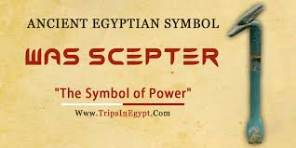

The Eye of Ra
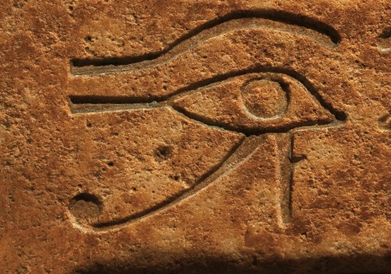
The Eye of Ra is one of the most famous Egyptian symbols even if it’s often confused with the Eye of Horus. While the latter is a symbol of health and unity, however, the Eye of Ra represents the absolute power and authority of the Sun God Ra and the pharaoh who ruled in his stead.

Alexander the Great

This star symbol with sixteen rays is the national Macedonian royal symbol of Phillip of Macedon, Alexander the Great, and the ancient Macedonian Empire. It is also known as the Macedonian Star, Macedonian Sun, Sun of Vergina, and Star of Vegina, after Macedonian royal tombs.

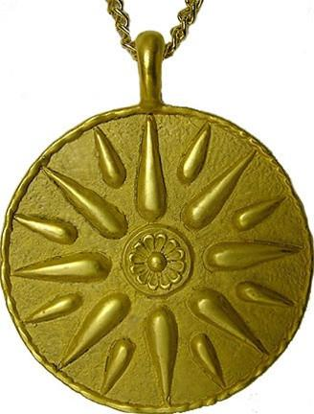

Nazi Germany

Swastika

In Mein Kampf, Adolf Hitler described the symbolism of the Nazi flag: "The red expressed the social thought underlying the movement. White the national thought. And the swastika signified the mission allotted to us—the struggle for the victory of Aryan mankind and at the same time the triumph of the ideal of creative work ..."^{[7]}

The Nazi Eagle is a symbol developed originally by the Nazi Party in Germany in the 1920s (also becoming a symbol of the German government after the Nazis took power), based loosely on traditional German coats of arms.

Napoleon

The day after the coronation, Napoleon had an eagle placed at the top of the shaft of every flag in the Napoleonic army. Symbol of immortality and resurrection, the bee was chosen so as to link the new dynasty to the very origins of France. They were considered as the oldest emblem of the sovereigns of France.

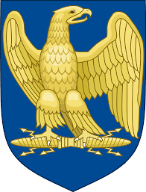

Babylon

The Lion of Babylon is an ancient Babylonian symbol. The Lion of Babylon symbolically represented the King of Babylon. The depiction is based on the Mesopotamian lion, which used to roam in the region.

Its most common traits are majesty, strength, courage, justice, and military might. It can be both solar and lunar. Commonly referred to as "the KING of the beasts," it is a symbol of kingly power and might, but as the lioness it is commonly related to the Great Mother and protection.

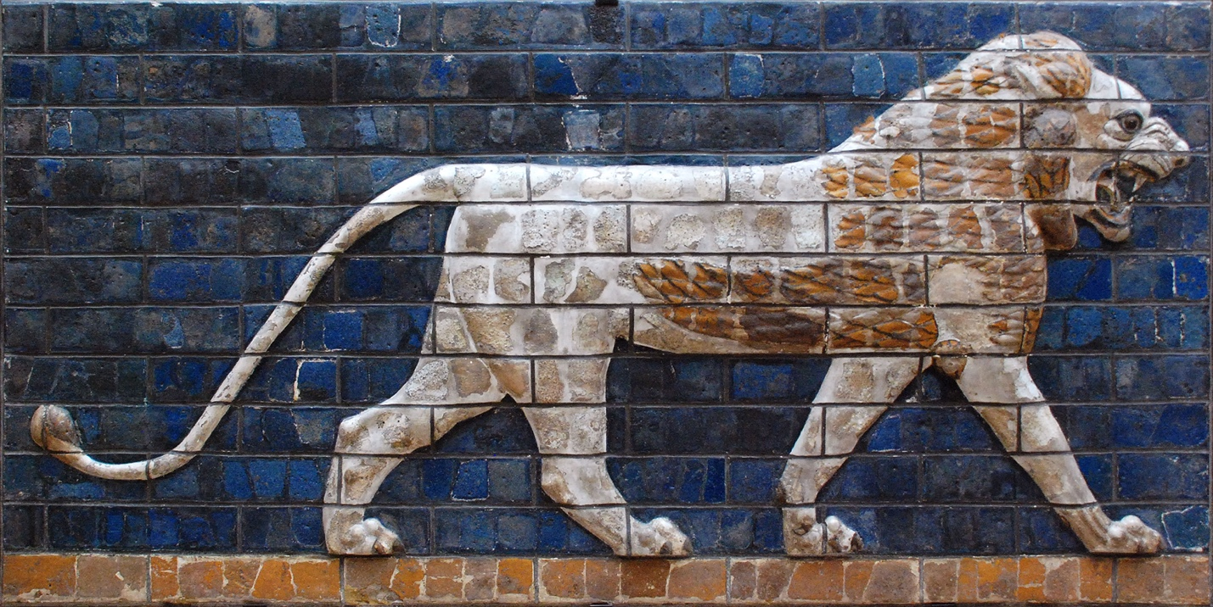

Roman Empire

The Eagle (Aquila)
Few symbols represent Rome as powerfully as the eagle. Perched atop the legionary standard, its wings outstretched, this ferocious hunting bird represented the span of the Roman Empire.

The Romans originally affixed several symbols to the top of their standards. As well as the eagle, they used the wolf, the horse, the boar, and the human-headed ox. Following Rome’s catastrophic defeat at the Battle of Arausio, however, and Gaius Marius’ radical overhaul of the Roman army in 104 BC, they abandoned these other symbols (signa manipuli, as they were called) leaving only the eagle.

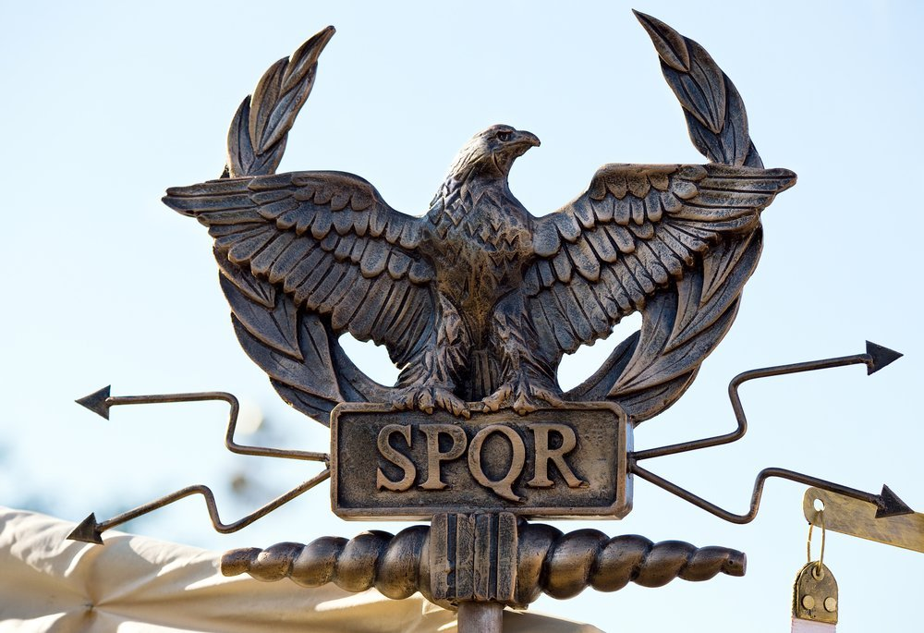

The Fasces
Originating not with the Romans but by the Etruscans, the fasces has become perhaps Rome’s most enduring international symbol. Compared to the eagle or the she-wolf, the symbol itself is visually little-known. Where it survives, however, is in language, where it gives us the root for the word ‘fascism’.

From the Roman Republic, the fasces consisted of a bundle of rods bound together around a single-headed axe. Carried by Roman magistrates in numbers depending on their status, the fasces were a pure symbol of power – of Rome’s dominion over her imperium (empire). The most powerful position possible, that of dictator, entitled the individual to 24 fasces.

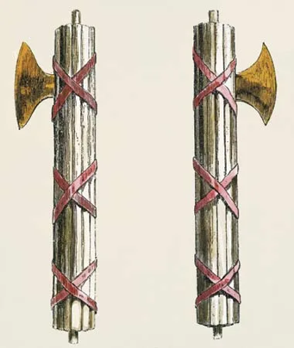

The Globe (Globus)
Another Roman symbol that has become part of our daily symbolic life is the globe. Held by the god of gods, Jupiter, as a symbol of his universal dominion, the globe was featured on many coins and statues throughout the Roman Empire. Sometimes portrayed under foot or in the emperor’s hand, it symbolised Roman dominion over all the territory they had conquered.

A coin minted under the emperor Hadrian shows the goddess Salus standing on a globe. The message is pretty unambiguous, and Hadrian himself spent most of his reign travelling the length and breadth of his empire while architects back in Italy realised projects like the Pantheon and Villa Adriana.

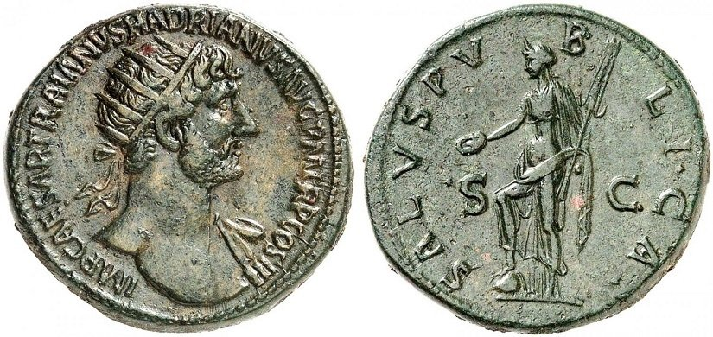

Constantine went even further in emphasising the extent of the Roman Empire’s dominion. A coin minted during his reign in the early 4th century shows the emperor holding a globe in his hand, attributing the dizzying extent of Rome’s territorial span to himself personally (Constantine never was one for modesty).
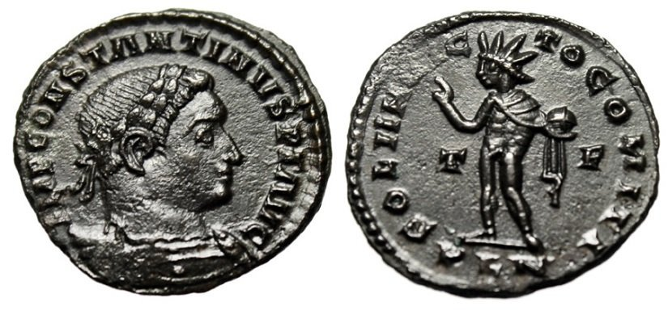
The ascendency of Christianity saw modifications to this symbol of Roman history. Most conspicuously was the addition of the crucifix atop the globe, which symbolised the Christian God’s dominion over everything. Still a prominent church symbol dating back from the 5th century, the globus cruciger manifests itself all across Christian art.

The Answer Man is Coming
Research
Microchip Implants and Implications to The Mark of the Beast

Description of microchip from Wikipedia:
A human microchip implant is any electronic device used to implant subcutaneous (subdermal). Examples include an identifying integrated circuit RFID device encased in silicate glass which is used to implant in the body of a human being. This type of subdermal implant usually contains a unique ID number that can be linked to information contained in an external database, such as personal identification, law enforcement, medical history, medications, allergies, and contact information.

Popular Usage
A list of popular uses for microchip implants are as follows;
- Access cards^{[29]}
- Payment cards^{[30][31]}
- Cryptocurrency wallet^{[32]}
- Travel cards^{[33]}

Risk to human freedom and autonomy
Some have expressed concerns that technology could be abused.^{[73]} Invasive technology has the potential to be used by governments to create an 'Orwellian' dystopia. In such a world, self-determination, the ability to think freely, and all personal autonomy would be completely lost; human beings would be essentially digital slaves to governments, corporations, or networks that owned the microchipping technology.^{[74][75][76]}
An example of a particular privacy concern is tagging criminals with RFID implants to track their location to provide updates on their whereabouts to authorities. These privacy concerns have been subject of ongoing debate. For example in Indonesia where it was proposed to tag sex offenders with RFID microchips.^{[77][better}

Potential Future Applications
In 2017, Mike Miller, chief executive of the World Olympians Association, was widely reported as suggesting the use of such implants in athletes in an attempt to reduce problems in sports due to recreational drug use.^{[84]}
Theoretically, a GPS-enabled chip could one day make it possible for individuals to be physically located by latitude, longitude, altitude, and velocity. Such implantable GPS devices are not technically feasible at this time. However, if widely deployed at some future point, implantable GPS devices could conceivably allow authorities to locate missing people and/or fugitives and those who fled from a crime scene. Critics contend, however, that the technology could lead to political repression as governments could use implants to track and persecute human rights activists, labor activists, civil dissidents, and political opponents; criminals and domestic abusers could use them to stalk and harass their victims; and child abusers could use them to locate and abduct children.
Another suggested application for a tracking implant, discussed in 2008 by the legislature of Indonesia's Irian Jaya would be to monitor the activities of people infected with HIV, aimed at reducing their chances of infecting other people.^{[85][86]} The microchipping section was not, however, included in the final version of the provincial HIV/AIDS Handling bylaw passed by the legislature in December 2008.^{[87]} With current technology, this would not be workable anyway, since there is no implantable device on the market with GPS tracking capability.
Since modern payment methods rely upon RFID/NFC, it is thought that implantable microchips, if they were to ever become popular in use, would form a part of the cashless society.^{[88]} Verichip implants have already been used in nightclubs such as the Baja club for such a purpose, allowing patrons to purchase drinks with their implantable microchip.
Market share of implanted individuals may possibly move on to more safer applications of wearable electronics and hardware such as Wearable computer.

In Popular Culture
Further information: New World Order conspiracy theory and Apocalypticism
The general public are most familiar with microchips in the context of identifying pets.
Some Christians make a link between the PositiveID and the Biblical Mark of the Beast,^{[89][90]} prophesied to be a future requirement for buying and selling, and a key element of the Book of Revelation.^{[91][92]} Gary Wohlscheid, president of These Last Days Ministries, has argued that "Out of all the technologies with potential to be the mark of the beast, VeriChip has got the best possibility right now".^{[93]} "Arkangel", an episode of the fictional drama series Black Mirror, considered the potential for helicopter parenting of an imagined more advanced microchip.
Transhumanism is a movement related the implants and their relation to trans human qualities of which microchipped/sub-dermal implanted individuals are commonly grouped together with.^{[94]}
Source:
https://en.wikipedia.org/wiki/Microchip_implant_(human)

The Medical Futurist - 18 July 2019

The first-ever human to receive an RFID microchip implant was British scientist Kevin Warwick (known by the moniker “Captain Cyborg”) in 1998. This experiment allowed a computer to monitor Warwick as he moved through halls and offices of the Department of Cybernetics at the University of Reading, using a unique identifying signal emitted by the implanted chip. He could operate doors, lights, heaters and other computers without lifting a finger. Approximately two decades later, the technology has been made commercially available, and thousands of people decided to implant an RFID chip. For example, groups of people have been meeting at “implant parties,” often organized by larger companies, to hook themselves up. It’s especially popular in Sweden, where more than 4,000 individuals can take pride in opening doors with only lifting their hands. So, why is the rush? And why should you consider implanting one?

In the future, an RFID chip implanted into your hand, between your thumb and your index finger on the back of your hand, could contain a lot of useful information – that you usually carry around in your wallet or purse. It could transmit your identity information as you walk through a security checkpoint, enable you to use public transport and make long lines at the supermarket checkout a thing of the past. You don’t have to worry about losing your most important documents or your wallet ever again – and ‘within hand’s reach’ will most certainly have a second layer of meaning to it. Moreover, imagine that in a medical emergency situation the first responders only have to scan your hand to get to know every valuable bit of medical data about you.

Source:
https://medicalfuturist.com/rfid-implant-chip/

August 10, 2020

Can A Chip Be Implanted in Humans?
Government GPS Implants to Come By 2025

When the Patriot Act opened Pandora’s Box to mass surveillance by the government, people everywhere saw their freedoms taken away inch-by-inch. This is how the government takes freedoms away from society: little-by-little. Therefore, it should be no surprise to anyone really paying attention that some powers are in discussions to implant RFID chips into people as early as 2025. In the same way, the government forced children to be pumped with vaccines to enter a school and refused education to those children who did not take the 100+ mandatory vaccinations, GPS implants will be sold to the public as a way to keep us safe. The RFID implant technology will be pushed as a way to allow police and first responders to quickly locate an individual if they are in need of help. And don’t be surprised when the GPS chips implanted in humans also have some other pseudo “health benefit” most likely sponsored by an authority figure such as Bill Gates.

Is the RFID Chip Going to Be Mandatory?
The good news is the government cannot force every single human to get a chip implanted in their body, but what they can do is not allow you to get on a flight, go to school, work at a hospital, or have access to other important programs. They will have all the cards and make life very difficult for anyone who refuses to get an implanted RFID chip.

What Will Happen if I Refuse the RFID Chip?
If you work for a company that requires a GPS microchip implant that job could fire you if you refuse implanted RFID chips. Some people will naturally take this issue all the way up to the Supreme Court on grounds of religious freedoms, but when safety is paramount the end result will be bad for the person refusing an RFID chip. As we learned In Trans World Airlines v. Hardison, 432 U.S. 63 (1977), the Supreme Court set limits to the accommodations that businesses were required to make for employees whose religious choices resulted in limited work on the Sabbath. Basically, if you refuse an implantable RFID you will be fired. This is how the government would employ a strategy to microchip people.

In Which States Are Mandatory Chip Implants Currently Illegal?
As we mentioned earlier, the government won’t force RFID technology into people through human microchipping but create an environment where people will voluntarily agree to implantable devices in the left hand or some other location in the body. This can easily be done with RFID technology that is now smaller than a grain of rice. Some companies might even throw a chipping party to make people forget about the mark of the beast technology. Currently, there is no legislation that has mandatory chip implants classified as illegal, which is shocking.

What GPS Microchip Implants Will Record
GPS tracking devices have the ability to determine where a person is located, how long they were at each location and the exact address of each place they went. The data from a GPS microchip will not only provide monitoring centers controlled by the government that give them the ability to see where you are at in real-time, but also view the historical data. This would allow them to know your religious identity, political affiliations, and other data that will help the government categorize you to determine if you are a threat.

There is no doubt that microchips will be used by the government to more closely monitor people. The questions isn’t if they will microchip people, but when they will use implantable RFID to create a digital identity for each person. Would you sign up for voluntary microchipping and allow access control by the government?

Source:
https://gpstrackerreviews.net/are-chips-being-implanted-in-humans/

COVID-19 can be diagnosed in 55 minutes or less with the help of programmed magnetic nanobeads and a diagnostic tool that plugs into an off-the-shelf cell phone, according to Rice University engineers.

The Rice lab of mechanical engineer Peter Lillehoj has developed a stamp-sized microfluidic chip that measures the concentration of SARS-CoV-2 nucleocapsid (N) protein in blood serum from a standard finger prick. The nanobeads bind to SARS-CoV-2 N protein, a biomarker for COVID-19, in the chip and transport it to an electrochemical sensor that detects minute amounts of the biomarker.

Source:
https://www.sciencedaily.com/releases/2021/02/210225143805.htm

Coronavirus: Bill Gates ‘microchip’ conspiracy theory and other vaccine claims fact-checked

Rumours took hold in March when Mr Gates said in an interview that eventually "we will have some digital certificates" which would be used to show who'd recovered, been tested and ultimately who received a vaccine. He made no mention of microchips.
That response led to one widely shared article, under the headline: "Bill Gates will use microchip implants to fight coronavirus".

The article makes reference to a study, funded by The Gates Foundation, into a technology that could store someone's vaccine records in a special ink administered at the same time as an injection.

However, the technology is not a microchip and is more like an invisible tattoo. It has not been rolled out yet, would not allow people to be tracked and personal information would not be entered into a database, says Ana Jaklenec, a scientist involved in the study.

Source:
https://www.bbc.com/news/52847648

A video shared over 27,100 times on Facebook implies that the COVID-19 vaccine will contain a tracking microchip that will be injected in the individuals that receive the COVID-19 vaccine once it is ready. This is false.

Source:
https://www.reuters.com/article/uk-factcheck-vaccine-microchip-gates-ma-idUSKBN28E286

Microchips in Healthcare
Microchipping humans isn’t new, especially in the healthcare sector. In 2004, Florida-based Applied Digital Solutions received FDA approval to market the use of Verichips: an ID chip implanted under the skin that would be used for medical purposes. The chip would contain a 16-digit number that could be scanned by medical personnel ranging from EMTs to doctors.
Also, Microchips Biotech is developing an implant that can store and release doses of medication on a pre-determined schedule. The process was tested on a group of women with osteoporosis, and the study reveals that the absorption levels between the microchipped group and the women taking medications on a daily basis were the same — in fact, dosing schedules were more consistent among the microchipped group.
Source:
https://www.luc.edu/digitalethics/researchinitiatives/essays/archive/2017/implantingmicrochipssignofprogressormarkofthebeast/

July 2017

Company’s staff to be implanted with microchips
In a move that sounds straight out of a science fiction novel, a US company says it will implant staff with microchips in an effort to simplify their work lives.

In a blog post, Three Square Market (32M) said it was offering “optional” implanted chip technology to all employees at a “chip party” on August 1.
It expected at least 50 staff to volunteer to undergo the procedure.
The chips, to be implanted in the webbing between each worker’s thumb and forefinger, will allow them to open doors, login to their computers, buy food using a self-checkout in their break room, and make photocopies, 32M said.
The Radio-Frequency Identification (RFID) chips use electromagnetic fields to identify electronically stored information and take just seconds to implant.
The company is partnering with Sweden’s Biohax International – which microchipped its own employees earlier this year – on the odd workplace initiative.
32M’s business revolves around setting up “micro markets” – mini convenience stories, featuring self-checkouts – in companies’ break rooms, and its chief executive Todd Westby said he expects both micro markets, and the use of microchips to pay for purchases at them, to take off elsewhere.
“We foresee the use of RFID technology to drive everything from making purchases in our office break room market, opening doors, use of copy machines, logging into our office computers, unlocking phones, sharing business cards, storing medical/health information, and used as payment at other RFID terminals,” he said.
“Eventually, this technology will become standardized allowing you to use this as your passport, public transit, all purchasing opportunities, etc.”

Source:
https://www.hcamag.com/ca/news/general/companys-staff-to-be-implanted-with-microchips/120664

Victory in Christ

Rev 15:2 And I saw something like a sea of glass mingled with fire, and those who have the victory over the beast, over his image and over his mark and over the number of his name, standing on the sea of glass, having harps of God.

